Saba Syed

syeds3@montclair.edu

Professor Katherine Herbert

CSIT 355-01: Database Systems

5 May 2022

Project Report

**URL of website**

Montclair State University

**Demo**

The accounts being used are the user view and admin view.

**Website Credentials**

User’s view has a username called user and password is user. The admin’s view username is admin and password is admin.

**Table of Contents**

Abstract………………………………………………………………………………………………….………...…...4

Business Plan Enhanced…..…………………………………………………………………………………….….…..4

Problem Analysis……………..………………..…………..…………………………………………….……..….…..4

Solutions…………….………………………………………...………………………………………………..…....…5

ER Diagram..………………………………………………………………………………………………..…….....…5

Logical Model……………………………………………………………………………………………..…….……..6

Tables……………………………………………………………..……………………………………………...…….7

Keys………………………………………………………………………………………………………..………......8

Application development…..…………………………………………………………………………………..………8

Shopper…..……………………………………………………………...……………………………………..………8

Creating an account…..……………………………………………………….………………………………...…...…8

Logging in……………………………………………………………………………………………………...……..10

Viewing the Landing Page………………………………………………………………………………………...….12

View one item to purchase in each category………………………………………………………………………….14

Adding at least two items to cart……………………………………………………………………………………...19

Purchasing cart………………………………………………………………………………………………………..23

Viewing order history…………………………………………………………………………………………….…..26

Search…………………………………………………………………………………………………………………29

Employees (Admin)......................................................................................................................................................31

Adding a product……………………………………………………………………………………………………..31

Removing a product………………………………………………………………………………………………….34

Employees……………………………………………………………………………………………………………43

Database design…………………………………………………………………………………………………..…..43

Test plans…………………………………………………………………………………………………………….45

Security………………………………………………………………………………………………………….……45

Results………………………………………………………………………………………………………………..45

Code dump………………………………………………………………………………………………..…………..46

Database dump……………………………………………………………………………………………………….78

Citation……………………………………………………………………………………………………………….85

**Abstract**

This project report is about the creation of NJ Pizzeria website for database systems. The details of what went into this project to create the database and make a functionally running website will be explained. The database aspect of a project is very important on the functionality of how data is being stored and used. The user’s information is being stored into the database. The website takes the data from the database to show results to the user.

**Business Plan Enhanced**

The group member and the client is Saba Syed. The type of users that will use the website is everyone. The reason behind the website is the site’s main idea is simple to create but not overly simple. The products on the website are Pizza, Specialty Pizza, Side Orders, Pastas, Salad, and Beverages. The pictures of the products are from google.

The views of the website are user and admin. The user is not allowed to do much on the website but to add products to their cart and check out. The admin has administrative functionalities which make the admin different from the user. The search bar allows the user and admin to search up product names. The admin is able to add products into the website, The admin is able to remove products. The modify function is the admin is able to edit the product. The user information is also able to change their email, address, and phone number.

**Analysis of the Client’s Needs**

The client wants to be able to add products to their cart. The user wants to use a delivery option to be able to have shipping information in the database. The user wants to be able to see the products, description, and price in the products page. The customers are hungry adults looking to buy pizza or pizza related products. The customer’s expectation is that they will be able to add items to their cart and check out with the option to pick up or deliver. The user should be able to add products into their cart.

**Summary of Problem**

The problem is users are hungry and want Italian food to buy then eat. The solution is allowing users to add products to their cart and to be able to check out with the product that is in their cart. The cart should also show the total amount of the cart. Also, allowing the users to input their delivery location to get their products delivered to them.

**Problem Analysis**

The assumption for the ER Diagram is that one user can make many orders. The user has the ability to make as many orders as they want. The order items will show the products of the order. The user must provide delivery details to their order. The user will not have the option to pick up their order. The user can add products into their cart. The products will be placed into categories for easier access for the user. The admin can add new products to the site.

**Anchor Concepts**

The anchor concepts are the tables main idea which for example for product the anchor is product and the variables in product table is related to the product.

**Anchors**

The anchors in this project is PRODUCT, CATEGORIES, ORDERS, ORDERITEMS, DELIVERYDETIALS, USERS, and CART.

**Interactions**

The Users have a relationship with the Cart because the users are inputting products into the cart. The Cart has a relationship with the Orders because the cart is creating the order. The Order has a relationship with the Orderitems because the Order has the Orderitems. The Order also has a relationship with Deliverydetails because the Order contains the Deliverydetails. The Order also has a relationship with Product because the Orders contains Product. The Product has a relationship with Categories because the Product are placed into categories.

**Solution**

**ER Diagram**

In Figure 1, explains that the admin manages all the features of the products. The products are placed into categories. The products are added to the cart. The cart creates an order and the order will have order details of the order that was made by the cart. The user has personal information that can be many. The user also has billing information that can be many. The order has billing information because the cart will put it through in the database. The billing information can be updated into the database. The order will be put into the database and the user can go through their previous orders.

Figure 1. First ER Diagram

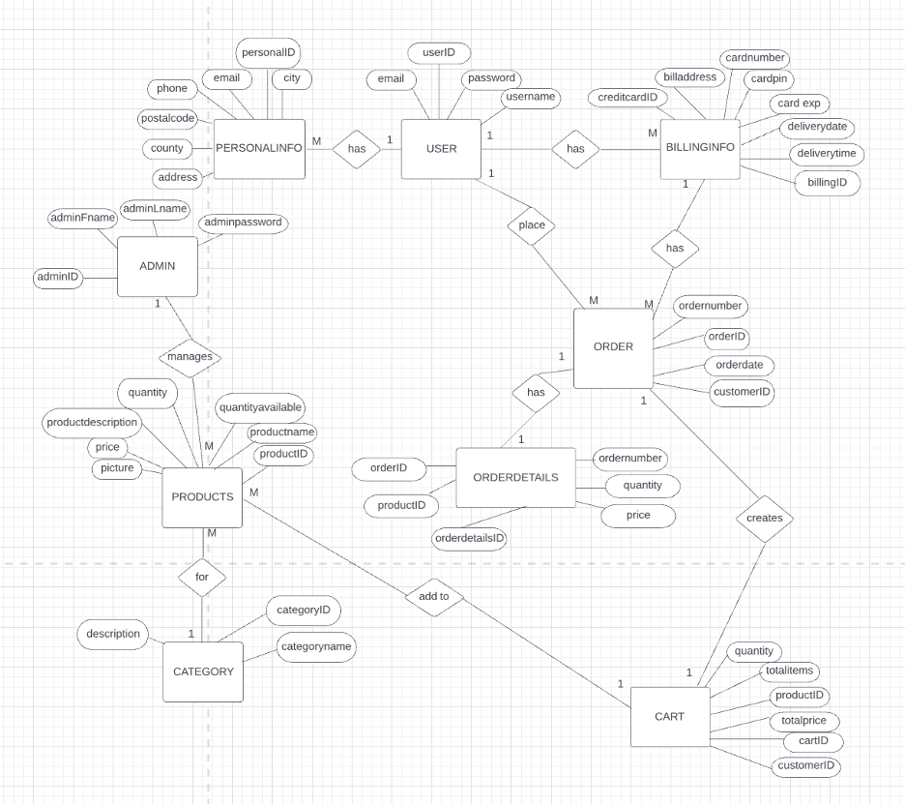

In Figure 2, explains that the user can be one to many and manage the cart which will contain information related to their cart. The cart creates one to many orders for the user. The orders contain one to many products in their order. The products are separated into their own categories. The orders have the order items of the user’s order. The order contains delivery details.

Figure 2. Final ER Diagram

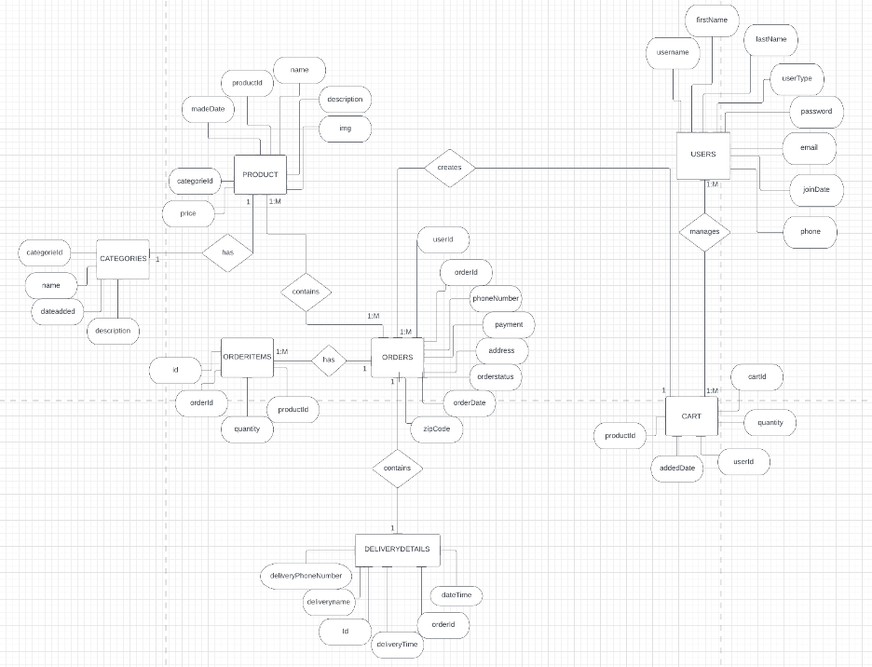

**Logical Model**

The anchors are deliverydetails, cart, orders, orderitems, categories, product and users. The simple attributes are listed in each table below. The title of the tables are the anchors and the columns are the attributes. These lists are handled so the user’s data can correctly go into the database. I did not make any weak entities that I know of. The relationships between these tables below are one to one or one to many. For product has one to one with categories. For deliverydetails has one to one with orders. For orderitems has one to many and one with orders. The products has one to many and one to many with orders. The cart has one and one to many with orders. The user has one to many and one to many with cart.

**CART**

|  |  |  |  |  |
| --- | --- | --- | --- | --- |
| **cartId** | **productId** | **quantity** | **userId** | **addedDate** |

## **CATEGORIES**



|  |  |  |  |
| --- | --- | --- | --- |
| **categorieId** | **name** | **description** | **dateadded** |

**DELIVERYDETAILS**

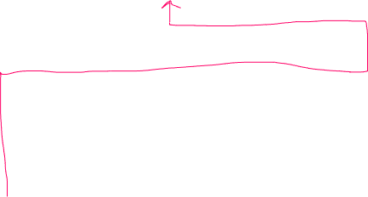

|  |  |  |  |  |  |
| --- | --- | --- | --- | --- | --- |
| **id** | **orderId** | **deliveryname** | **deliveryPhoneNumber** | **deliveryTime** | **dateTime** |

## **ORDERITEMS**

|  |  |  |  |
| --- | --- | --- | --- |
| **id** | **orderId** | **productId** | **quantity** |

## **ORDERS**

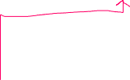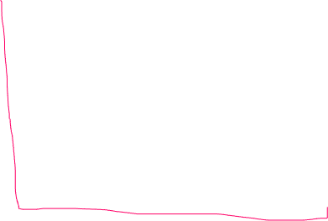

|  |  |  |  |  |  |  |  |  |
| --- | --- | --- | --- | --- | --- | --- | --- | --- |
| **orderId** | **userId** | **address** | **zipCode** | **phoneNumber** | **amount** | **payment** | **orderstatus** | **orderDate** |

## **PRODUCT**

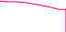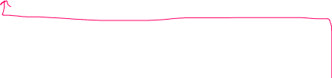

|  |  |  |  |  |  |  |
| --- | --- | --- | --- | --- | --- | --- |
| **productId** | **name** | **price** | **description** | **categorieId** | **img** | **madeDate** |



## **USERS**

|  |  |  |  |  |  |  |  |  |
| --- | --- | --- | --- | --- | --- | --- | --- | --- |
| **id** | **username** | **firstName** | **lastName** | **email** | **phone** | **userType** | **password** | **joinDate** |

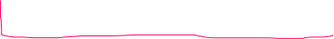

**Keys**

The attribute that would be specified as not null are the primary keys, unique keys, etc. In table cart the cartId, productId, quantity, userId, addedDate are all not null. In table categories the categorieId, name, description, dateadded are all not null. In deliverydetails table the id, orderId, deliveryname, deliveryPhoneNumber, deliveryTime, datetime are not null. In the ordersitems table the id, orderId, productId, quantity are all not null. In the orders table the orderId, userId, address, zipCode, phoneNumber, amount, orderDate are all not null. In the products table the productId, name, price, description, categorieId, img, madeDate are all not null. In users table, the id, username, firstName, lastName, email, phone, userType, password, joinDate are not null.

For cart table, the primary key is cartId. For categories table, the primary key is categorieId. For deliverydetails table, the primary key is id and the unique key is orderId. For orderitems table, the primary key is id. For orders table, the primary key is orderId For product table, the primary key is productId. For users table, the primary key is id and the unique key is username. The foreign key from cart table is productId and userId. The foreign key from delivery details table is orderId. The foreign key from order items is productid and orderId. The foreign key from orders table is userId. The foreign key from the product table is categorieId. I chose these keys to be the primary keys because they are unique to their particular table.

**Application Development**

**Shopper**

**Creating an account**

*Figure 3. Creating an Account*

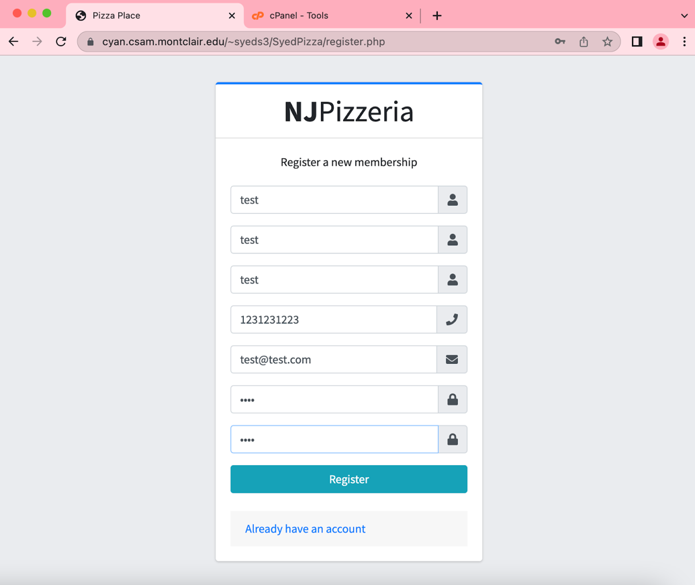

The user must fill in their information and press register to create their account. This information will then save into the database.

**SQL/PHP statement for creating an account**

function register($fname, $lname, $uname, $email, $phone, $pwd)

{

    global $db;

    try {

        $query = "INSERT INTO `users`( `username`, `firstName`, `lastName`, `email`, `phone`, `userType`, `password`)  VALUES ('$uname','$fname', '$lname', '$email', '$phone',TRUE, '$pwd')";

        $result = $db->query($query);

        echo $result;

    } catch (Exception $e) {

        $error_message = $e->getMessage();

        echo $error_message;

        header("Location: ../register.php?msg='$error_message'");

    }

    // checks for successful result

    if ($result) {

        $query = "SELECT * FROM users WHERE username = '$uname'";

        $result = $db->query($query);

        $row = $result->fetch_assoc();

        if($row['userType'] == 0)

            {

                $_SESSION['isAdmin'] = 'FALSE';

            }

            else

            {

                $_SESSION['isAdmin'] = 'TRUE';

            }

        if (isset($_SESSION['loggedin'])) {

            $userID = $row['id'];

            echo 'User.' . $userID;

            header('Location: ../products.php?userid=' . $userID);

        } else {

            session_start();

            $_SESSION['userID'] = $row['id'];

            $_SESSION['loggedin'] = TRUE;

            $result->free();

            header('Location: ../products.php');

            exit;

        }

    } else {

        header('Location: ../register.php?msg=error');

    }

}

**Explanation**

The reason why I wrote the sql code this way is to make it easier to read. I did run into errors that I was able to figure out. The $query needed to be wrote as “INSERT INTO `users`(`username`, `firstName`, `lastName`, `email`, `phone`, `userType`, `password`) VALUES ('$uname','$fname', '$lname', '$email', '$phone',TRUE, '$pwd')";” [3]. To fetch the data from the database, I got the information from another sorce to help me to solve the problem [4].

**Logging in**

*Figure 4. Login Email*

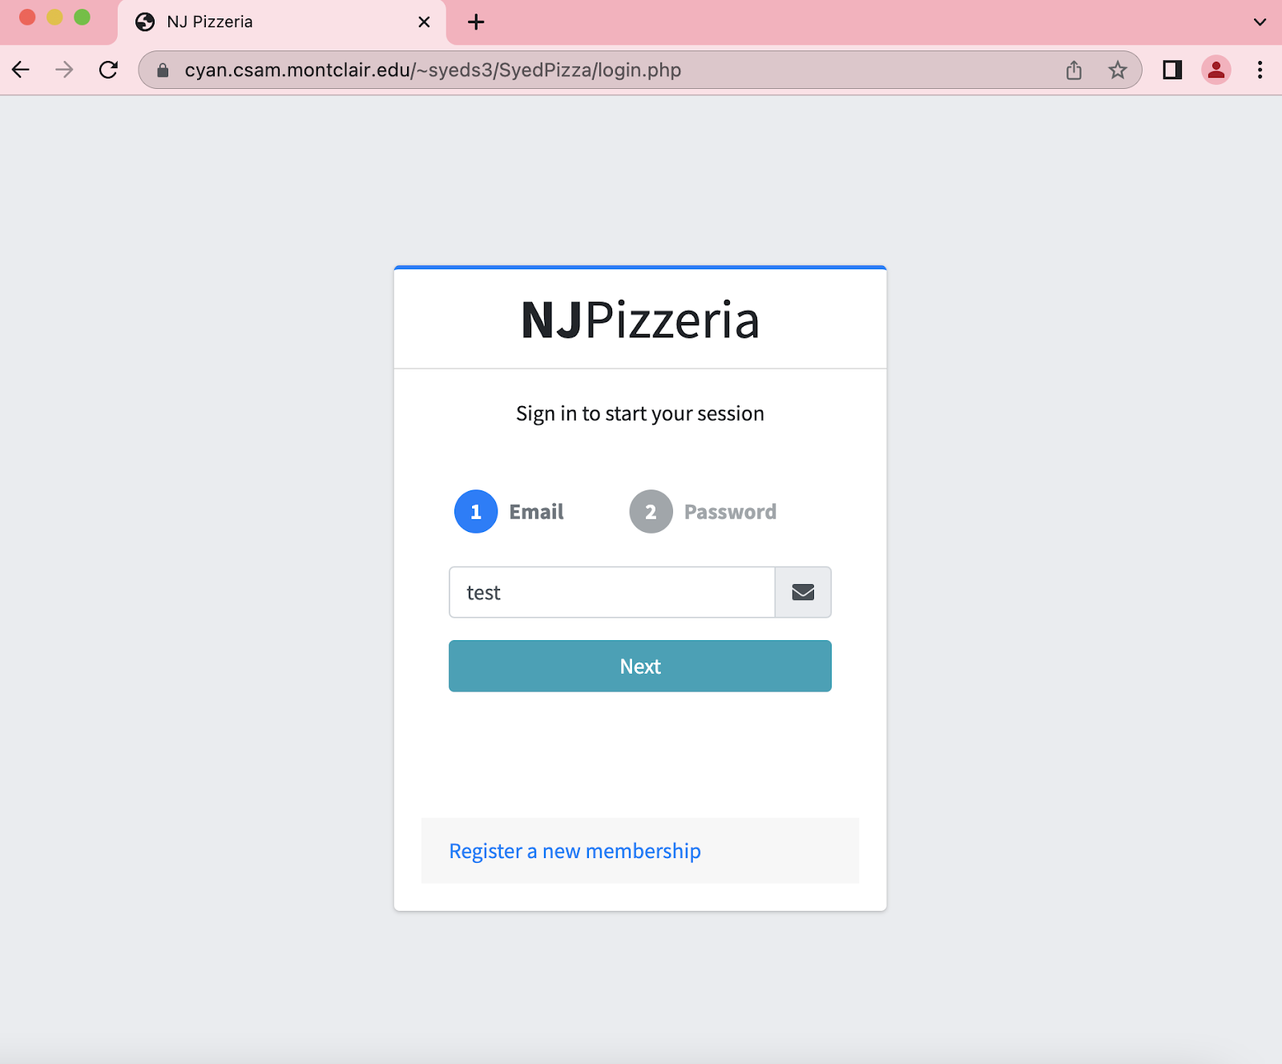

The user must enter their email or username to the email text box after writing in their username or email the user must press next to show the next step.

*Figure 5. Login Password*

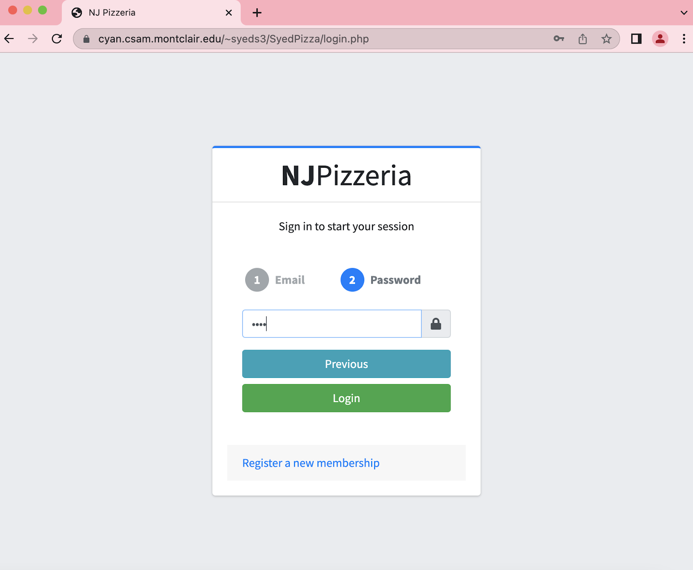

The user must fill in their password that they used to create their account to login and press login to enter their account

.

**SQL/PHP statement for logging in**

**function login($uname, $pwd)**

**{**

**session_start();**

**global $db;**

**$query = "SELECT * FROM users WHERE username = '$uname'";**

**$result = $db->query($query);**

**$row = $result->fetch_assoc();**

**$confirmPass = $row['password'];**

**if (mysqli_num_rows($result) == 0) {**

**header('Location: ../login.php?msg=error');**

**exit;**

**}**

**if ($pwd != $confirmPass) {**

**echo $pwd;**

**header('Location: ../login.php?msg=incorrectpass');**

**$result->free();**

**} else {**

**$_SESSION['userID'] = $row['id'];**

**$_SESSION['loggedin'] = TRUE;**

**$_SESSION['isAdmin'] = $row['userType'];**

**$result->free();**

**header('Location: ../products.php');**

**}**

**}**

<?php

$uname = $_POST['username'];

$pwd = $_POST['pwd'];

include 'dbCode.php';

login($uname, $pwd);

**Explanation**

The user username and password are being verified from the database. When the username and password match the session of the website will begin for the user. The inspiration of writing the login in this manner comes from online source [4].

**Viewing the landing page**

*Figure 6. Landing Page*

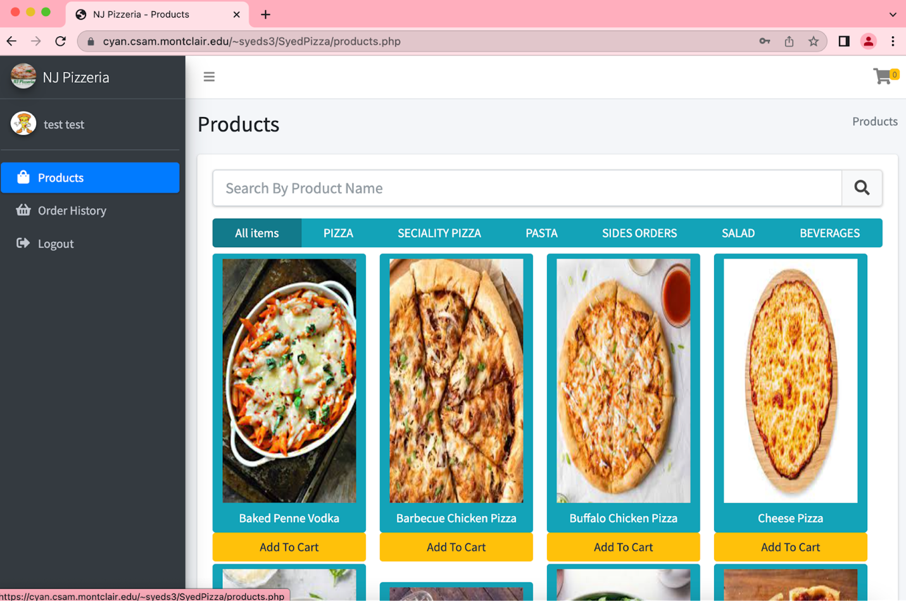

The landing page displays the products and their images. Also, in the landing page is the nav bar for easier access for the user.

**SQL/PHP statement for viewing the landing page**

<?php

$products = getAllProducts();

$num_results = $products->num_rows;

if ($num_results != 0) {

while ($row = $products->fetch_assoc()) {

echo '<div class="filtr-item col-sm-3 divProducts" data-category="'. $row['categorieId'] .'" data-sort="white sample">';

echo '<a class="btn btn-info" href="dist/img/'. $row['img'] .'" data-toggle="lightbox" data-img="'. $row['img'] .'" data-footer="'. $row['description'] .'" data-title="'. $row['name'] .' - $'. $row['price'] .'">';

echo '<img src="dist/img/'. $row['img'] .'" class="img-fluid mb-2 productImg" alt="'. $row['name'] .' - $'. $row['price'] .'"/>';

echo '<span class = "productNameSpan"> '. $row['name'] .' </span> ';

echo '</a>';

echo '<form action="FunctionsCode/manageCartCode.php" method="POST">';

echo '<input type="hidden" name="itemId" value="'.$row['productId']. '">';

$numExistRows = checkCartItemForUser($row['productId'],$_SESSION['userID']);

if($numExistRows > 0){

echo '<button type="submit" name="removeItem" class="btn btn-danger col-md-12">Remove From Cart</button>';

}

else{

echo '<button type="submit" name="addToCart" class="btn btn-warning col-md-12">Add To Cart</button>';

}

echo '</form>';

echo '</div>';

}

}

**Explanation**

The products.php is the landing page and in the products page the first tab of the categories shows the products from all the categories. The all of the products are being fetched from the database. The user also has the ability to add the item to the cart which will then will activate the manageCartCode.php to update its information. There was some errors intitally but I was able to solve the problem with the num-rows [5].

**View one item to purchase in each category**

*Figure 7. All Products*

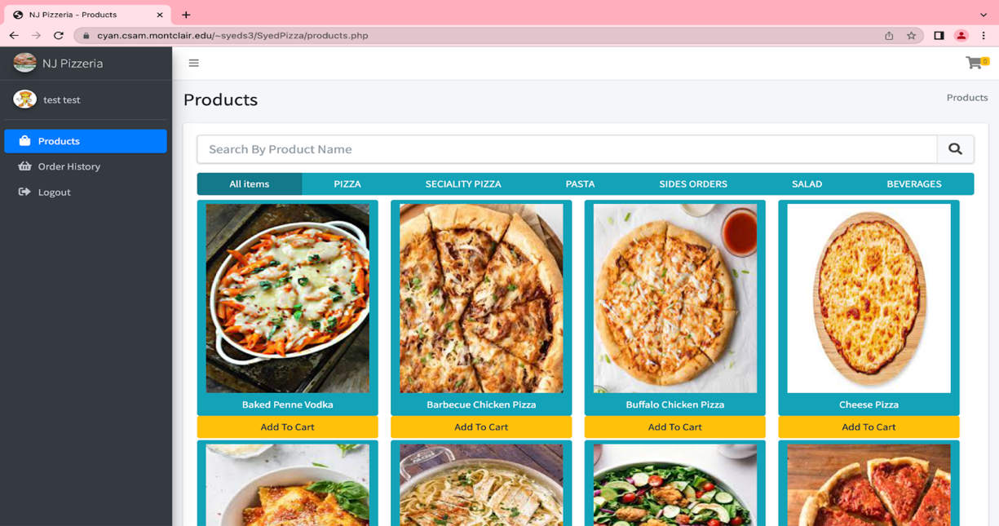

In Figure 7, the All Products shows all the products available.

*Figure 8. Pizza Products*

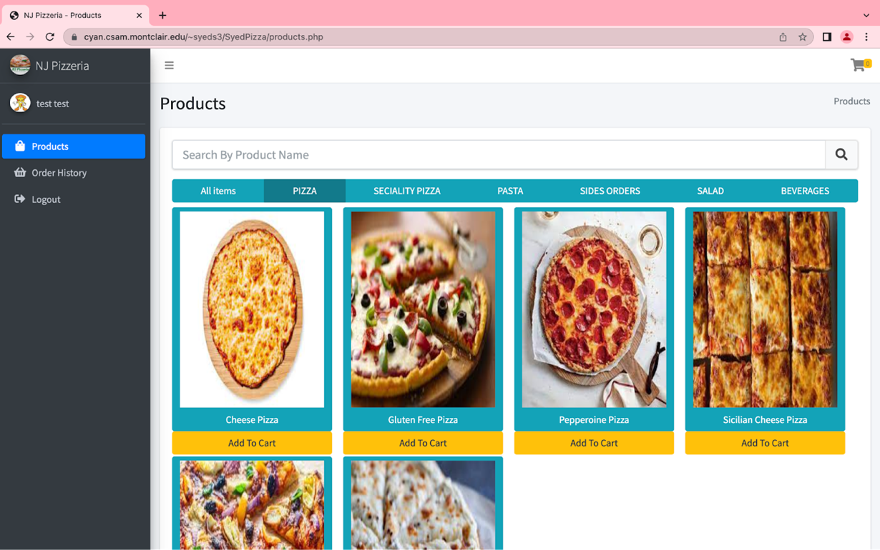

In Figure 8, the Pizza tab shows the normal pizzas to the user.

*Figure 9. Specialty Pizza*

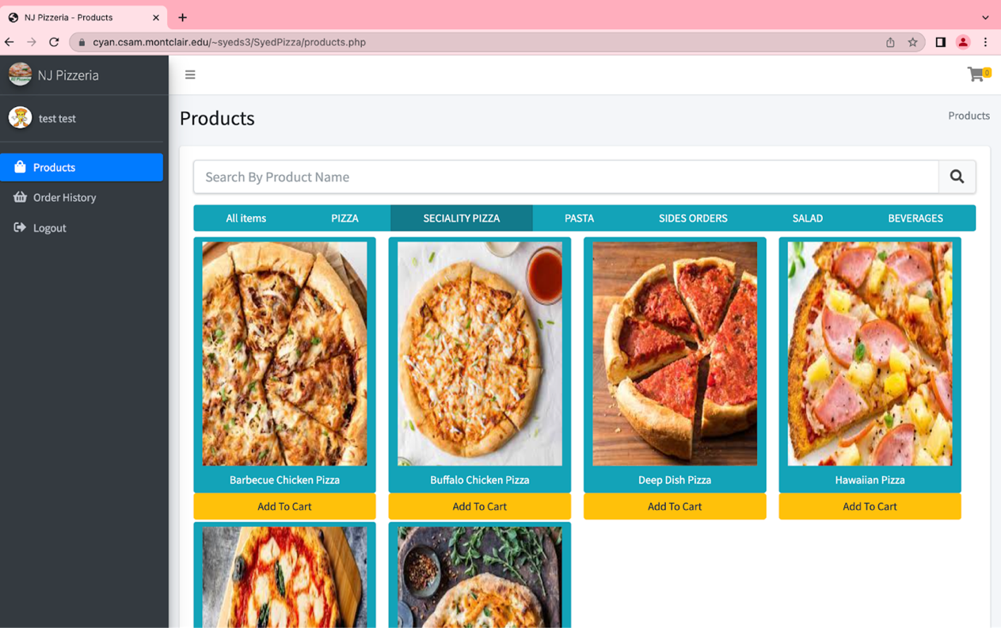

In Figure 9, the Specialty Pizza shows the pizzas available to order.

*Figure 10. Pasta*

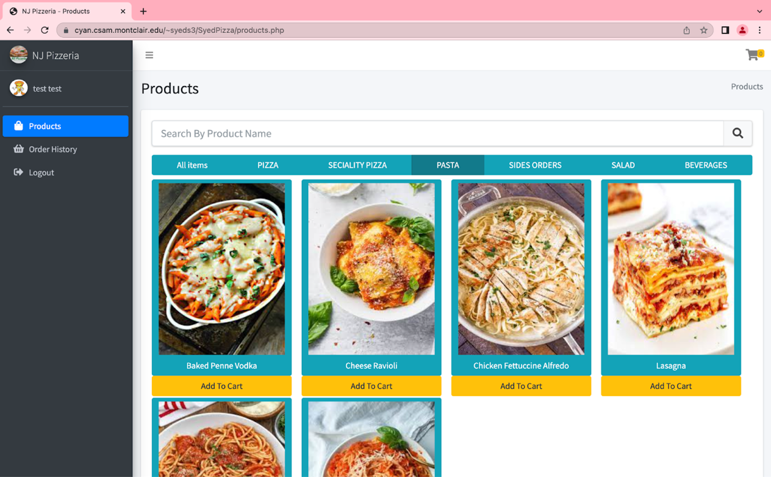

In Figure 10, the Pasta tab shows all the pasta items available.

*Figure 11. Sides Orders*

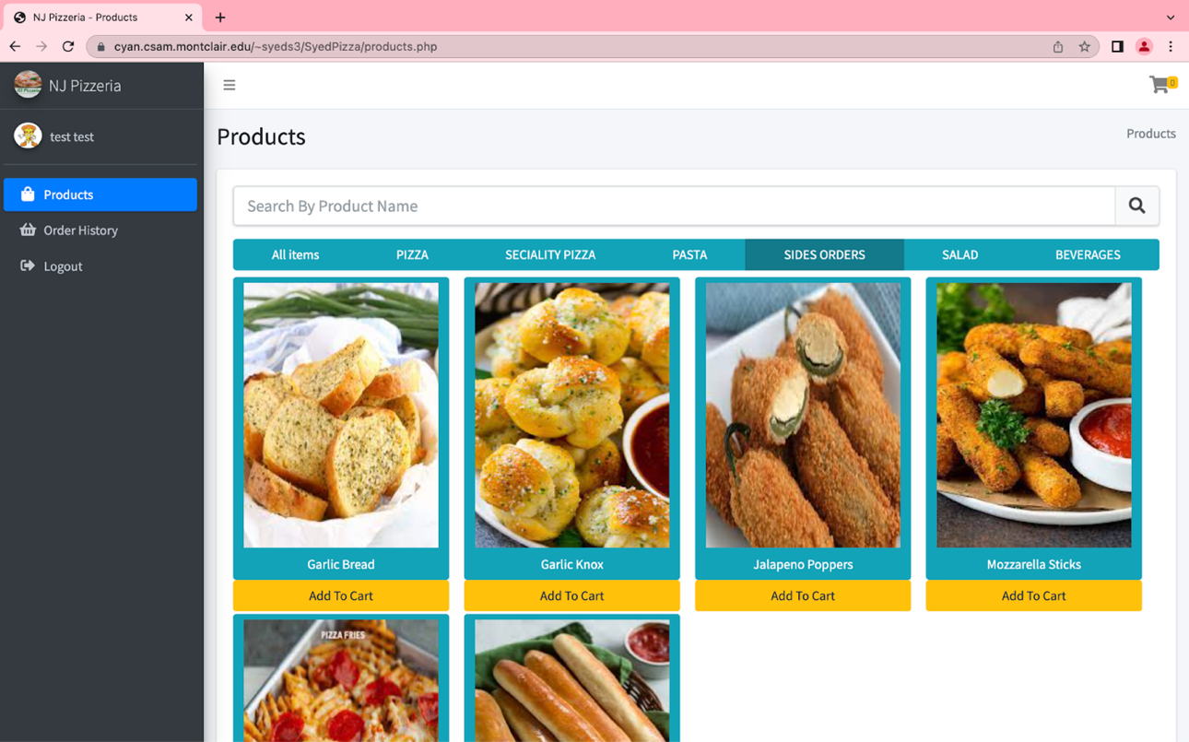

In Figure 11, the Side Orders tab shows all the side orders.

*Figure 12. Salad*

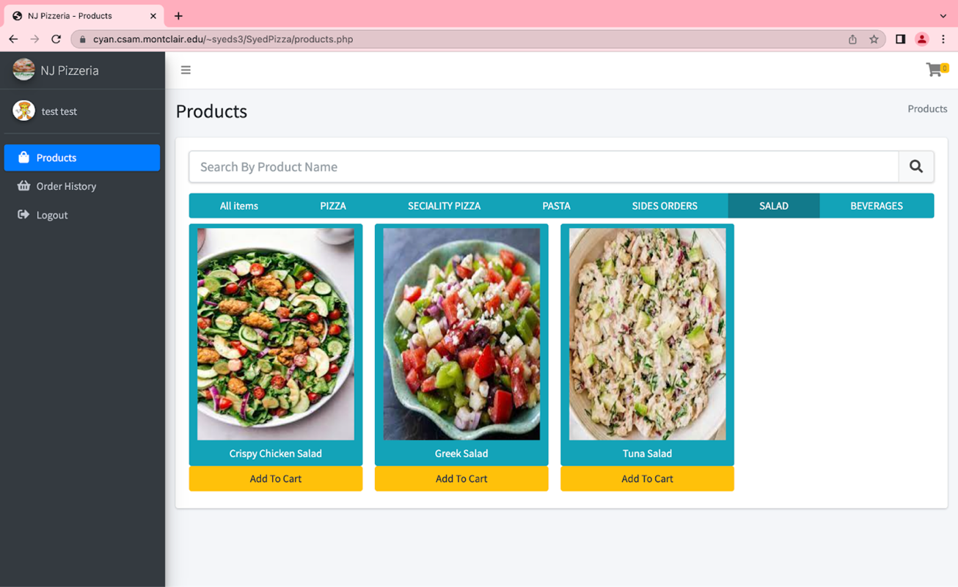

In Figure 12, the Salad tab shows all the salads available to the user.

*Figure 13. Beverages*

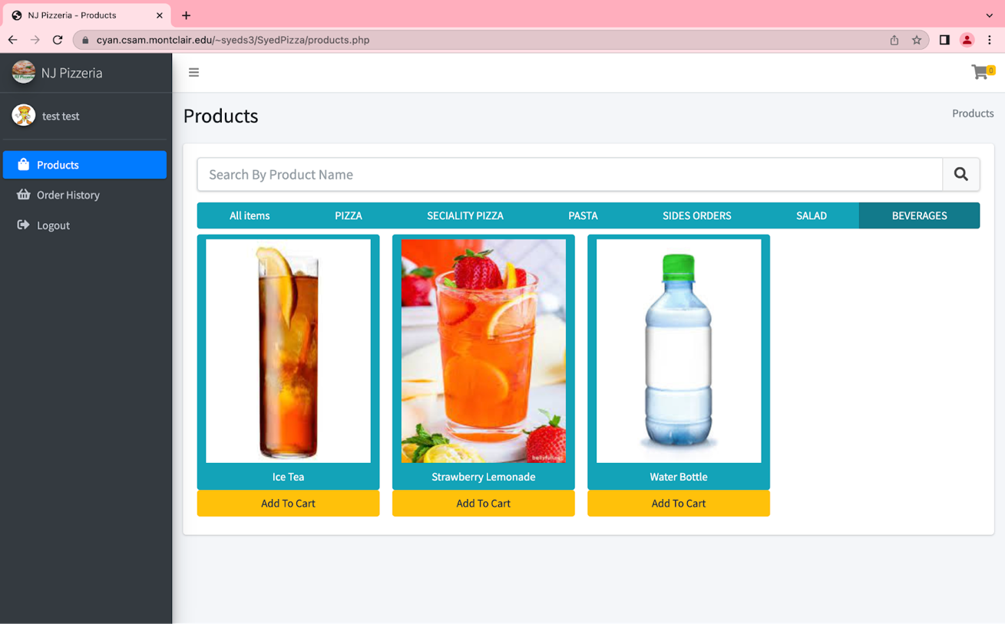

In Figure 13, the Beverages tab showed all the beverages available.

**SQL/PHP statement for viewing product in their category**

**// gets all categories**

**function getAllCategories()**

**{**

**global $db;**

**$query = "SELECT * FROM categories";**

**$result = $db->query($query);**

**return $result;**

**}**

**// get category name by ID**

**function getCategoryName($catID)**

**{**

**global $db;**

**$query = "SELECT `name` FROM categories where `categorieId` = '$catID'";**

**$result = $db->query($query);**

**return $result->fetch_assoc();**

**}**

<?php

$categories = getAllCategories();

$num_results = $categories->num_rows;

if ($num_results != 0) {

while ($row = $categories->fetch_assoc()) {

echo '<a class="btn btn-info" href="javascript:void(0)" data-filter="' . $row['categorieId'] . '">' . $row['name'] . '</a>';

}

<?php

$products = getAllProducts();

$num_results = $products->num_rows;

if ($num_results != 0) {

while ($row = $products->fetch_assoc()) {

echo '<div class="filtr-item col-sm-3 divProducts" data-category="'. $row['categorieId'] .'" data-sort="white sample">';

echo '<a class="btn btn-info" href="dist/img/'. $row['img'] .'" data-toggle="lightbox" data-img="'. $row['img'] .'" data-footer="'. $row['description'] .'" data-title="'. $row['name'] .' - $'. $row['price'] .'">';

echo '<img src="dist/img/'. $row['img'] .'" class="img-fluid mb-2 productImg" alt="'. $row['name'] .' - $'. $row['price'] .'"/>';

echo '<span class = "productNameSpan"> '. $row['name'] .' </span> ';

echo '</a>';

echo '<form action="FunctionsCode/manageCartCode.php" method="POST">';

echo '<input type="hidden" name="itemId" value="'.$row['productId']. '">';

$numExistRows = checkCartItemForUser($row['productId'],$_SESSION['userID']);

if($numExistRows > 0){

echo '<button type="submit" name="removeItem" class="btn btn-danger col-md-12">Remove From Cart</button>';

}

else{

echo '<button type="submit" name="addToCart" class="btn btn-warning col-md-12">Add To Cart</button>';

}

echo '</form>';

echo '</div>';

}

}

?>

**Explanation**

There is a loop in the categories to display the correct information into their category name. There was some problems with this not displaying anything or not to the correct information but I was able to resolve it. The loop begins with the while statement [6].

**Adding at least 2 different items to cart**

*Figure 14. First Product Added to Cart*

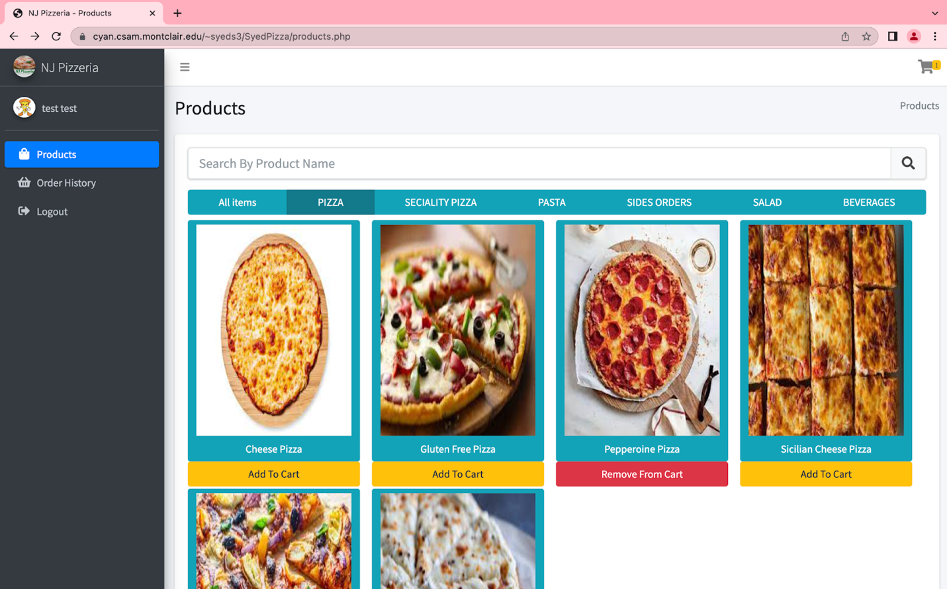

*Figure 15. Displaying the Item in the Cart for First Item*

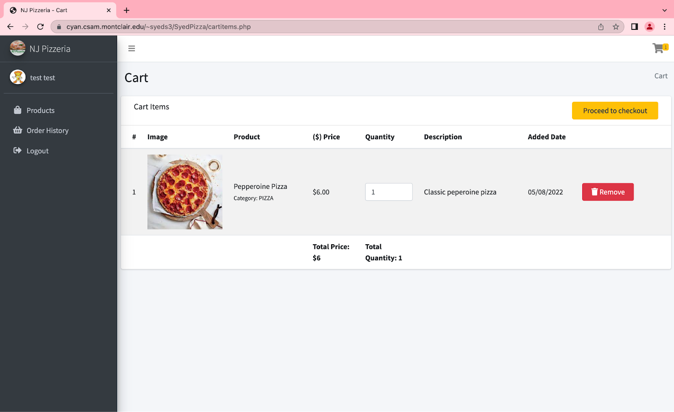

*Figure 16. Adding Second Item to Cart*

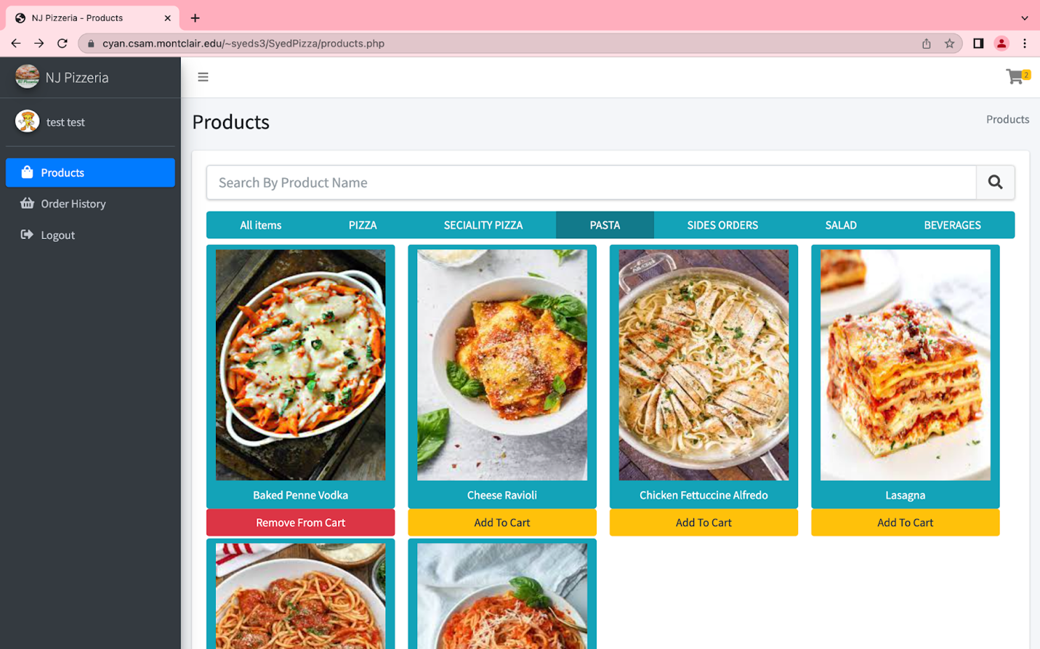

*Figure 17. Displaying Second Item in the Cart*

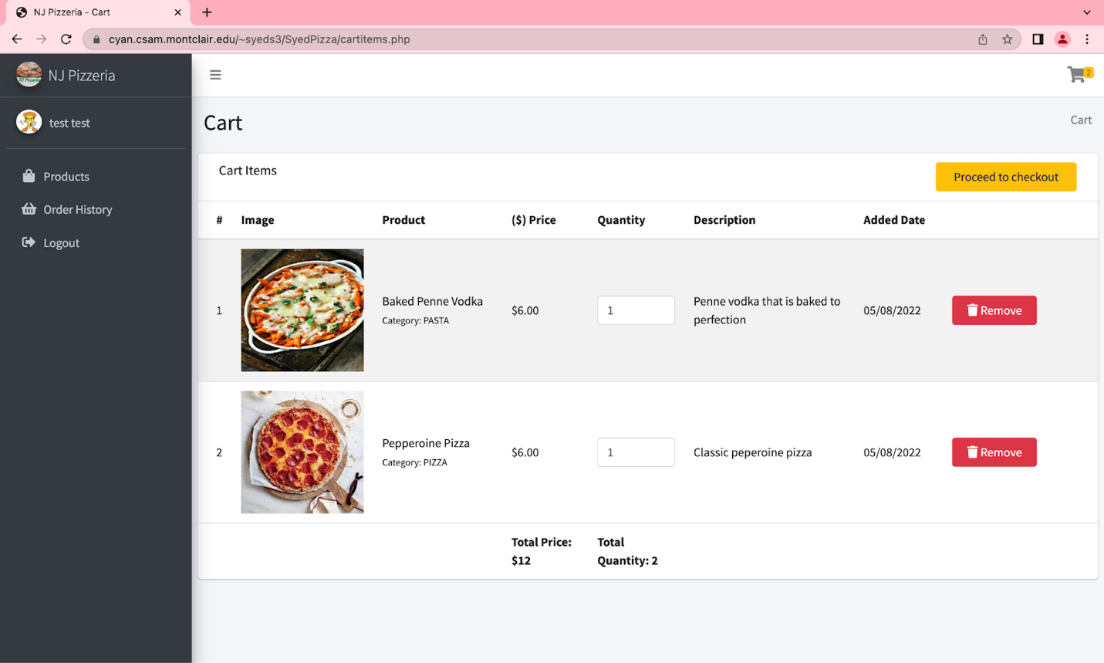

The user has now added two different items into their cart.

**SQL/PHP statement for adding two items to the cart**

**// cart count**

**function countCartItemsForUser($userId)**

**{**

**global $db;**

**$query = "SELECT * FROM `cart` WHERE `userId`='$userId'";**

**$result = $db->query($query);**

**$numExistRows = mysqli_num_rows($result);**

**return $numExistRows;**

**}**

**//get cart items**

**function getCartItemsForUser($userId)**

**{**

**global $db;**

**$query = "SELECT * FROM `cart` WHERE `userId`='$userId' ORDER BY `addedDate` DESC";**

**return $result = $db->query($query);**

**}**

**//update cart quantity**

**function updateCartQuantity($cartID,$quan)**

**{**

**global $db;**

**$query = "UPDATE`cart` SET `quantity`= '$quan' WHERE `cartId`='$cartID'";**

**$result = $db->query($query);**

**return $result;**

**}**

<?php

if ($num_results != 0) {

$i = 1;

$totalPrice = 0;

$totalQuantity = 0;

while ($row = $allCartItems->fetch_assoc()) {

echo '<tr>';

echo '<td>';

echo $i;

$product = getSingleProduct($row['productId']);

$category = getCategoryName($product['categorieId']);

echo '</td>';

echo '<td>';

echo '<img src="dist/img/'. $product['img'] .'" alt="Product Image Here" class = "productImg" />';

echo '</td>';

echo '<td>';

echo '<a>'. $product['name'] .' </a> <br/> <small> Category: '. $category['name'] .' </small> ';

echo '</td>';

echo '<td>';

$totalQuantity = $totalQuantity + intval($row['quantity']);

$totalPrice = $totalPrice + (intval($product['price']) * intval($row['quantity']));

echo '<span>$'. $product['price'] .'</span>';

echo '</td>';

echo '<td>';

echo '<form name="quanForm" action="FunctionsCode/updateCartQuantity.php" method = "POST">';

echo '<input type="number" name="quantity" onkeyup="updateCartQuantity(this)" onmouseup="updateCartQuantity(this)" value="'. $row['quantity'] .'" min="1" class="form-control"/>';

echo '<input type="hidden" name="cartID" value="'. $row['cartId'] .'"/>';

echo '<button type="submit" name="updateQuan" hidden></button>';

echo '</form>';

echo '</td>';

echo '<td>';

echo '<span>'. $product['description'] .'</span>';

echo '</td>';

echo '<td>';

echo '<span>'. DateTime::createFromFormat("Y-m-d H:i:s",$row['addedDate'])->format("m/d/Y") .'</span>';

echo '</td>';

echo '<td class="project-actions">';

echo '<form action="FunctionsCode/manageCartCode.php" method="POST">';

echo '<input type="hidden" name="itemId" value="'.$row['productId']. '">';

echo '<button type="submit" name="removeItem" class="btn btn-danger col-md-8">';

echo '<i class="fas fa-trash"> </i>';

echo ' Remove</button>';

echo '</form>';

echo '</td>';

echo '</tr>';

$i++;

}

}

if($_SERVER["REQUEST_METHOD"] == "POST") {

$userId = $_SESSION['userID'];

if(isset($_POST['addToCart'])) {

$itemId = $_POST["itemId"];

// Check whether this item exists

$numExistRows = checkCartItemForUser($itemId,$userId);

if($numExistRows > 0){

echo "<script>

window.history.back(1);

</script>";

}

else{

$sql = "INSERT INTO `cart` (`productId`, `quantity`, `userId`, `addedDate`) VALUES ('$itemId', '1', '$userId', current_timestamp())";

$result = mysqli_query($conn, $sql);

if ($result){

echo "<script>

window.history.back(1);

</script>";

}

}

}

**Explanation**

The query is getting the results from the database. The way I wrote the code, I got inspiration from online source [7]. The functions in dbCode.php is updating the information in the cart. The information is being updated into the database when the user adds an item to the cart.

**Purchasing the Cart**

*Figure 18. Purchasing Cart*

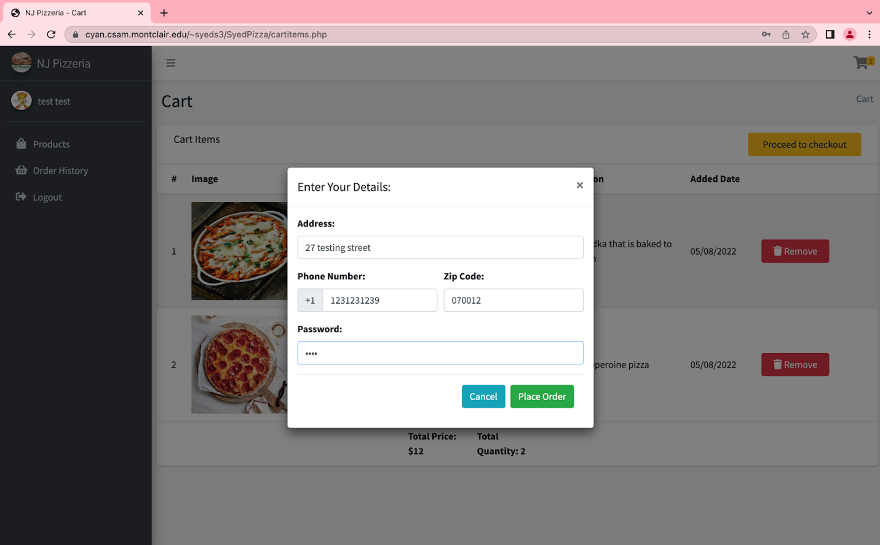

When checking out the user must enter their information and their password to be able to check out.

**SQL/PHP statement for purchasing the cart**

session_start();

if($_SERVER["REQUEST_METHOD"] == "POST") {

$userId = $_SESSION['userID'];

if(isset($_POST['checkout'])) {

$amount = $_POST["amount"];

$address = $_POST["address"];

$phone = $_POST["phone"];

$zipcode = $_POST["zipcode"];

$password = $_POST["password"];

$passSql = "SELECT * FROM users WHERE id='$userId'";

$passResult = mysqli_query($conn, $passSql);

$passRow=mysqli_fetch_assoc($passResult);

$userName = $passRow['username'];

if ($password == $passRow['password']){

$sqlOrder = "INSERT INTO `orders` (`userId`, `address`, `zipCode`, `phoneNumber`, `amount`, `payment`, `orderStatus`, `orderDate`) VALUES ('$userId', '$address', '$zipcode', '$phone', '$amount', '0', '0', current_timestamp())";

$result = mysqli_query($conn, $sqlOrder);

$orderId = $conn->insert_id;

if ($result){

$addSql = "SELECT * FROM `cart` WHERE userId='$userId'";

$addResult = mysqli_query($conn, $addSql);

while($addrow = mysqli_fetch_assoc($addResult)){

$productId = $addrow['productId'];

$itemQuantity = $addrow['quantity'];

$itemSql = "INSERT INTO `orderitems` (`orderId`, `productId`, `quantity`) VALUES ('$orderId', '$productId', '$itemQuantity')";

$itemResult = mysqli_query($conn, $itemSql);

}

$deletesql = "DELETE FROM `cart` WHERE `userId`='$userId'";

$deleteresult = mysqli_query($conn, $deletesql);

echo '<script>alert("Thanks for ordering with us. Your order id is ' .$orderId. '.");

window.history.back(1);

</script>';

exit();

}

}

else{

echo '<script>alert("Incorrect Password! Please enter correct Password.");

window.history.back(1);

</script>';

exit();

}

}

}

if(isset($_POST['checkout'])) {

$amount = $_POST["amount"];

$address1 = $_POST["address"];

$address2 = $_POST["address1"];

$phone = $_POST["phone"];

$zipcode = $_POST["zipcode"];

$password = $_POST["password"];

$address = $address1.", ".$address2;

$passSql = "SELECT * FROM users WHERE id='$userId'";

$passResult = mysqli_query($conn, $passSql);

$passRow=mysqli_fetch_assoc($passResult);

$userName = $passRow['username'];

if (password_verify($password, $passRow['password'])){

$sql = "INSERT INTO `orders` (`userId`, `address`, `zipCode`, `phoneNo`, `amount`, `payment`, `orderStatus`, `orderDate`) VALUES ('$userId', '$address', '$zipcode', '$phone', '$amount', '0', '0', current_timestamp())";

$result = mysqli_query($conn, $sql);

$orderId = $conn->insert_id;

if ($result){

$addSql = "SELECT * FROM `cart` WHERE userId='$userId'";

$addResult = mysqli_query($conn, $addSql);

while($addrow = mysqli_fetch_assoc($addResult)){

$productId = $addrow['productId'];

$itemQuantity = $addrow['itemQuantity'];

$itemSql = "INSERT INTO `orderitems` (`orderId`, `productId`, `itemQuantity`) VALUES ('$orderId', '$productId', '$itemQuantity')";

$itemResult = mysqli_query($conn, $itemSql);

}

$deletesql = "DELETE FROM `cart` WHERE `userId`='$userId'";

$deleteresult = mysqli_query($conn, $deletesql);

echo '<script>alert("Thanks for ordering with us. Your order id is ' .$orderId. '.");

window.location.href="http://localhost/OnlinePizzeria/index.php";

</script>';

exit();

}

}

**Explanation**

Since, the project can’t get/take an actual payment, I decided to make the user input their shipping information to pay on delivery. The password is check from the database and when it matches the user is then able to checkout. If the password does not match, then the user can not checkout [8].

**Viewing order history**

*Figure 19. View Order History*

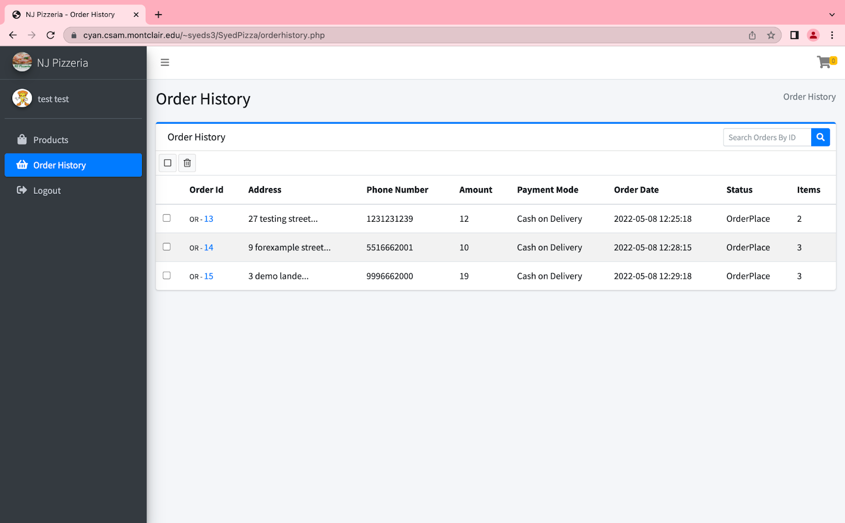

In Figure 19, the user is viewing their order history which is representing their pervious orders. The order history tab can show the last previous orders that the user made.

*Figure 20. Searching one Order*

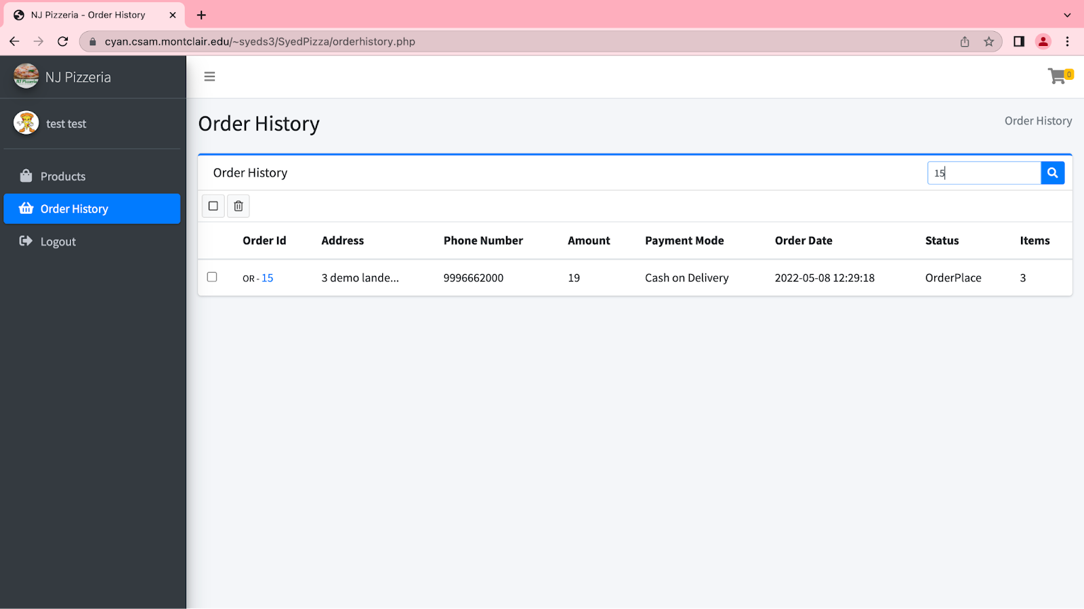

In Figure 20, the user is searching a specify order to see the order of.

*Figure 21. Order of QR- 15*

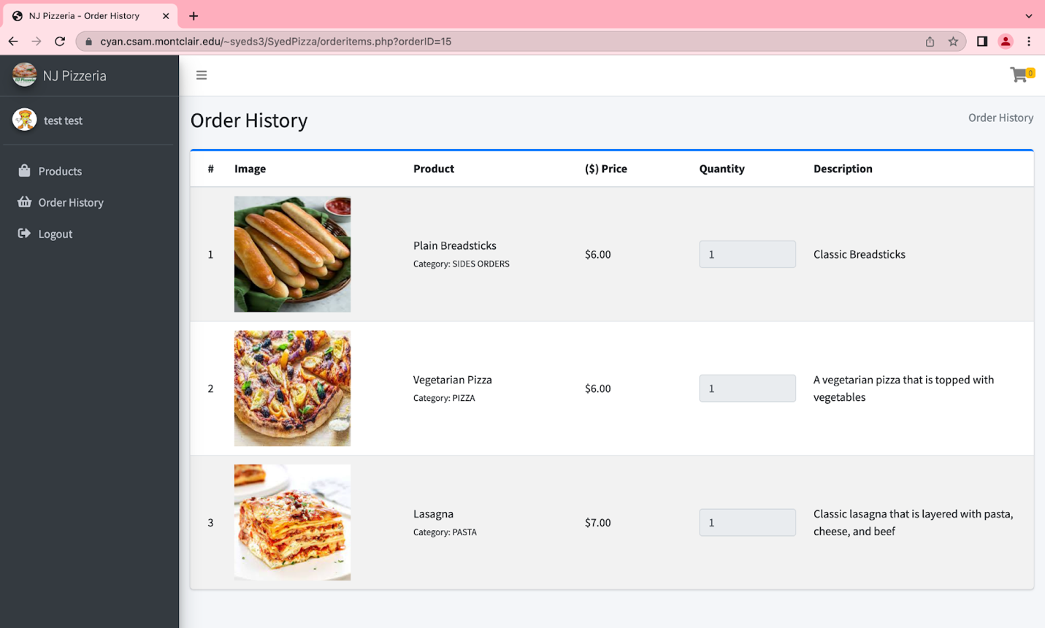

In Figure 21, the order history is displaying the orderID of 15 which the user pressed on to see their order.

**SQL/PHP statement for viewing the order history**

//get order items

function getOrderItemsForOrder($orderID)

{

    global $db;

    $query = "SELECT * FROM `orderitems` WHERE `orderId`='$orderID'";

    return $result = $db->query($query);

}

<?php

$userId = $_SESSION['userID'];

$sql = "SELECT * FROM `orders` WHERE `userId`= $userId";

$result = mysqli_query($conn, $sql);

$counter = 0;

while($row = mysqli_fetch_assoc($result)){

$orderId = $row['orderId'];

$address = $row['address'];

$zipCode = $row['zipCode'];

$phoneNumber = $row['phoneNumber'];

$amount = $row['amount'];

$orderDate = $row['orderDate'];

$payment = $row['payment'];

if($payment == 0) {

$payment = "Cash on Delivery";

}

else {

$payment = "Online";

}

$orderStatus = OrderStatus(intval($row['orderStatus']));

$sqlItems = "SELECT * FROM `orderitems` WHERE `orderId`= $orderId";

$resultItems = mysqli_query($conn, $sqlItems);

$totalItems = $resultItems->num_rows;

$counter++;

echo '<tr class="orderTR">

<td><div class="icheck-primary"><input type="checkbox" value="" name="OrderCheckbox"><label for="OrderCheckbox"></label></div></td>

<td><small>OR - </small><a href="orderitems.php?orderID='. $orderId .'" class="orderIDA">' . $orderId . '</a></td>

<td>' . substr($address, 0, 20) . '...</td>

<td>' . $phoneNumber . '</td>

<td>' . $amount . '</td>

<td>' . $payment . '</td>

<td>' . $orderDate . '</td>

<td><span>' . OrderStatus($orderStatus) . '</span></td>

<td><span>' . $totalItems . ' </span></td>

</tr>';

}

E**xplanation**

To create the order history, I did use Stack Overflow to help me to get started [9]. To receive the correct order status of the user and to display the correct information.

**Search**

**The actual search interface**

*Figure 22. Search of Products*

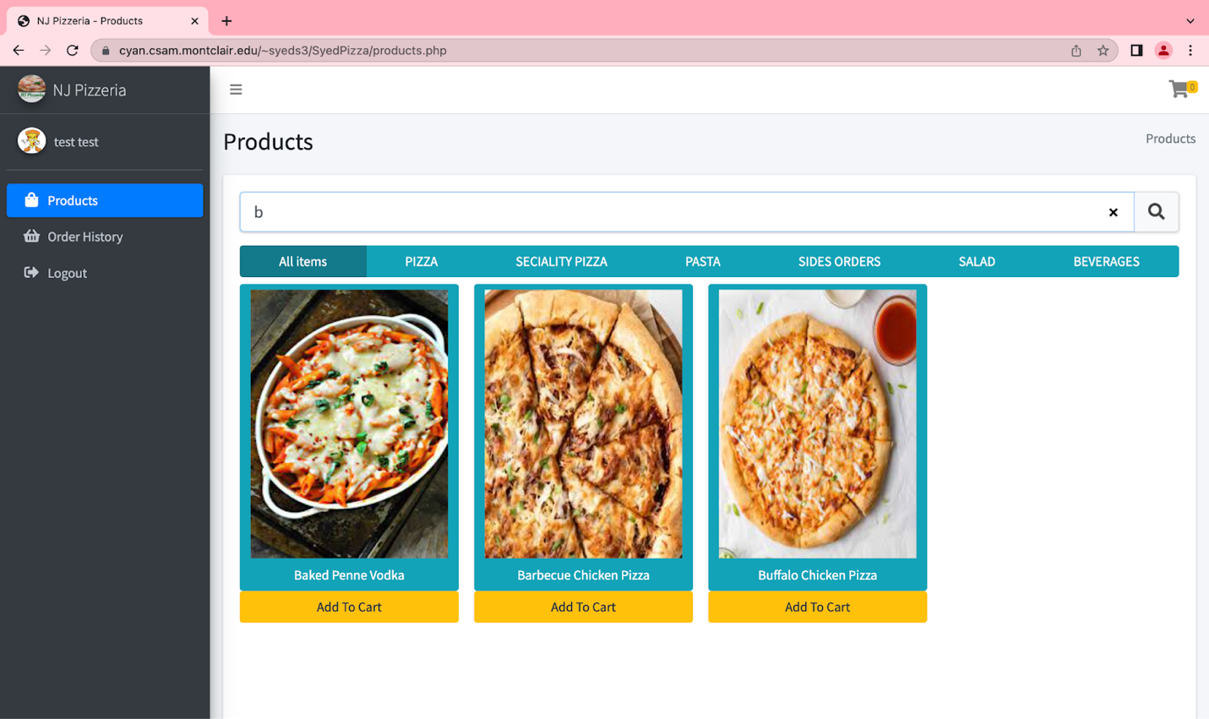

In Figure 22, The user can search for products on the landing page.

**JQuery statement for search interface**

$('#searchedProduct').on('keyup',function(){

var searchValue = $(this).val();

var spanProducts = $('.productNameSpan');

var divProducts = $('.divProducts');

var checkLength = spanProducts.length;

for(var i = 0; i < checkLength; i++)

{

var productName = $.trim($(spanProducts[i]).text());

if (!productName.toLowerCase().startsWith(searchValue.toLowerCase())) {

$(divProducts[i]).hide();

} else {

$(divProducts[i]).show();

}

}

});

**Explanation**

To make the order history, I did use Stack Overflow to help me to get started [9]. Then, I was able to understand how to create the order history for users.

**The result of the search**

*Figure 23. Results of the Search*



In Figure 23, the results of the search that the user entered into the search textbox.

**JQuery statement for results of the search**

$(function () {

$(document).on('click', '[data-toggle="lightbox"]', function(event) {

event.preventDefault();

$(this).ekkoLightbox({

alwaysShowClose: true

});

});

$('.filter-container').filterizr({gutterPixels: 3});

$('.btn[data-filter]').on('click', function() {

$('.btn[data-filter]').removeClass('active');

$(this).addClass('active');

});

})

**Explanation**

The reason why I used jQuery is because it was easier for me to understand. I was running into errors when using php. The inspiration of the code came from Stack OverFlow[10]. Then, I ran out of time to change it back to PHP and mySQL.

**Employees (Admin)**

**Adding a User**

*Figure 24. Adding a User*

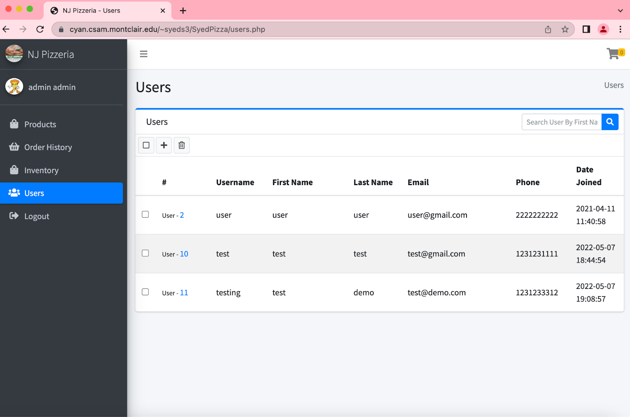

In Figure 24, the admin going to press on the plus button to create an account for a user.

*Figure 25. Enter User Details* 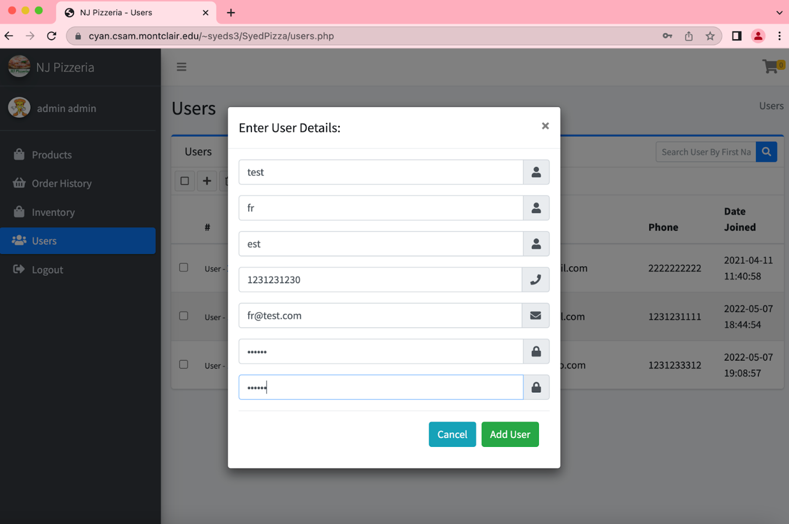

In Figure 25, the admin will then enter the user’s personal details.

*Figure 26. New Account Created*

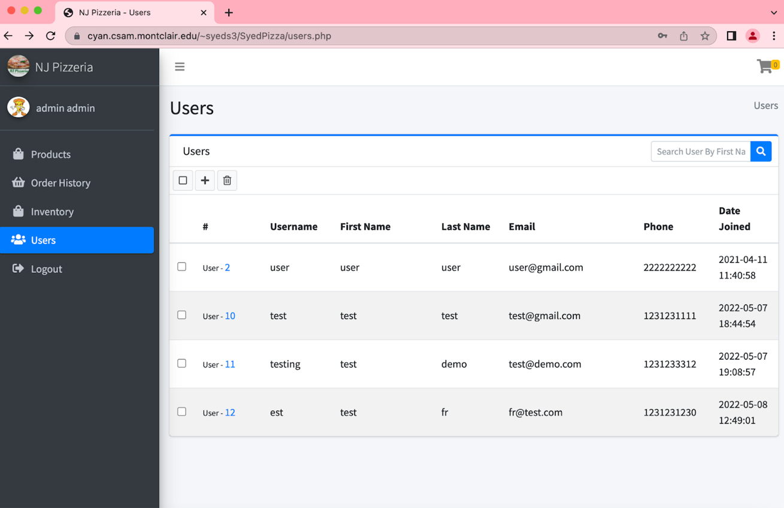

In Figure 26, the new account that the admin was creating is now into the system.

**SQL/PHP statement for adding a new user**

**//add user**

**function addUser($uname, $fname, $lname, $email,$phone,$pwd)**

**{**

**global $db;**

**try{**

**$query = "INSERT INTO `users`( `username`, `firstName`, `lastName`, `email`, `phone`, `userType`, `password`)  VALUES ('$uname','$fname', '$lname', '$email', '$phone',TRUE, '$pwd')";**

**$result = $db->query($query);**

**echo '<script>alert("' .$uname. ' is added.");**

**window.history.back(1);**

**</script>';**

**exit();**

**}**

**catch (Exception $e) {**

**$error_message = $e->getMessage();**

**echo '<script>alert("' .$error_message. '");**

**window.history.back(1);**

**</script>';**

**exit();**

**}**

**}**

<?php

include 'dbCode.php';

session_start();

if($_SERVER["REQUEST_METHOD"] == "POST") {

if(isset($_POST['Add'])) {

$fname = $_POST['firstName'];

$lname = $_POST['lastName'];

$uname = $_POST['username'];

$email = $_POST['email'];

$phone = $_POST['phnNum'];

$pwd = $_POST['pass'];

addUser($uname, $fname, $lname, $email,$phone,$pwd);

}

}

?>

**Explanation**

The reason for me creating the user was easier to understand. I used an outside source to make the create the account working for the user [11].

**Delete a User**

The admin is allowed to remove products.

**SQL/PHP statement for remove a user**

**// Delete user Details**

**function deleteUserDetails($userID)**

**{**

**global $db;**

**$query = "DELETE FROM `users` WHERE `id`=$userID";**

**$result = $db->query($query);**

**echo 'True';**

**}**

**<?php**

**$userID = $_POST['$userID'];**

**include 'dbCode.php';**

**deleteUserDetails($userID);**

**Explanation**

The removing products is not working on cPanel. I’m not sure why because it is working on other web hosting servers. The code, I am using is from Stack Overflow [12].

**Update User Information**

*Figure 27. Update Account Info*

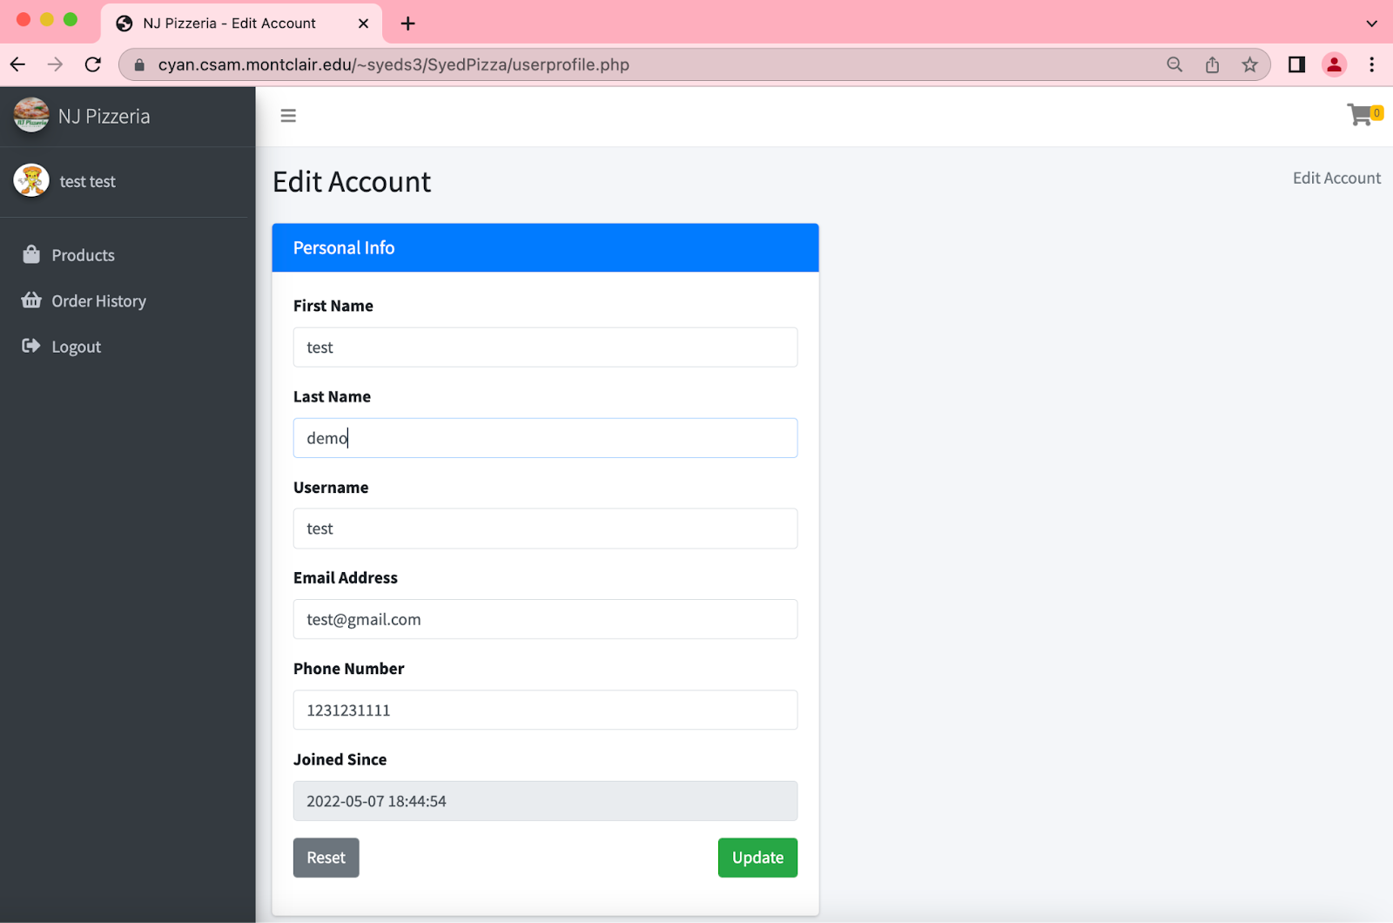

In Figure 27, the user is able to update their account information.

*Figure 28. Update* 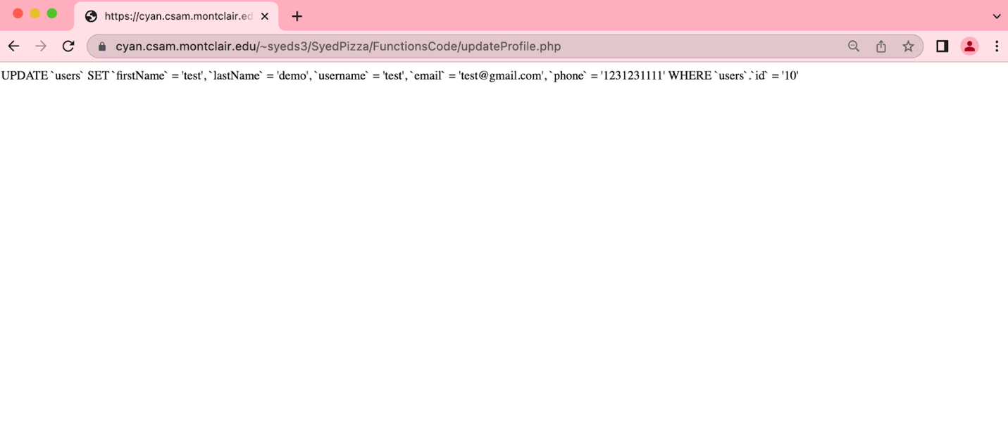

In Figure 28, the information is updated into the database.

**SQL/PHP statement for updating their information**

//update user profile

function updateuUserProfile($userID, $fname, $lname, $uname, $email, $phone)

{

    global $db;

    $query = "UPDATE `users` SET `firstName` = '$fname', `lastName` = '$lname', `username` = '$uname', `email` = '$email', `phone` = '$phone' WHERE `users`.`id` = '$userID'";

    echo $query;

    $result = $db->query($query);

    if (!$result) {

        echo 'Error updating info.';

    } else {

        if (isset($_SESSION['userID'])) {

            header("Location: ../products.php");

            exit;

        }

    }

}

<?php

session_start();

if (!isset($_SESSION['userID'])) {

header('Location: ../login.php');

exit;

}

include 'dbCode.php';

$userID = $_SESSION['userID'];

if (isset($_POST['updateInfo'])) {

$fname = $_POST['fname'];

$lname = $_POST['lname'];

$uname = $_POST['uname'];

$email = $_POST['email'];

$phone = $_POST['phone'];

updateuUserProfile($userID, $fname, $lname, $uname, $email, $phone, $addr);

}

**Explanation**

I used online source to help me figure out how to post the information to the database. The information became very useful and help me integrate the code so it was functional [13].

**Add a Product**

*Figure 29. Adding a New Product*

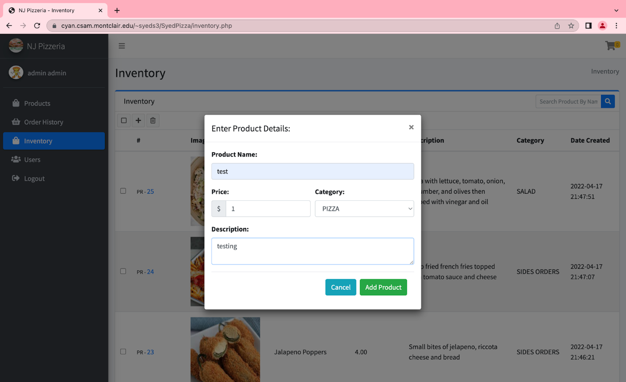

In Figure 29, the admin is able to add a new product by providing the product details.

*Figure 30. New Product in the System* 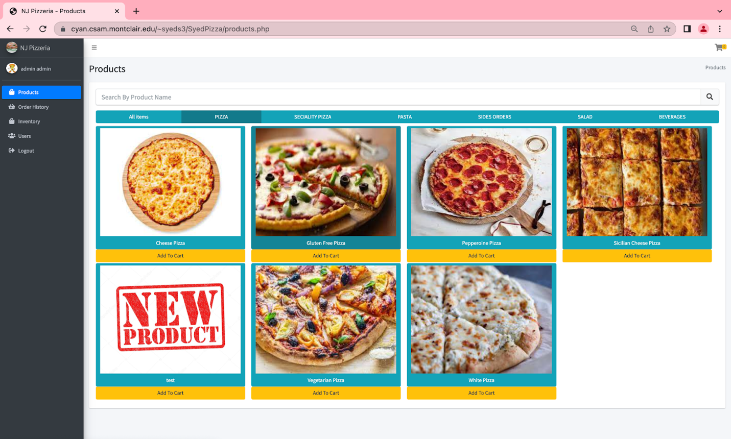

In Figure 30, the new product is now added to the pizza products because that is what the user selected as the category.

**SQL/PHP statement for add a new product**

**//add Product**

**function addProduct($prodName, $price, $description, $category)**

**{**

**global $db;**

**try{**

**$query = "INSERT INTO `product` ( `name`, `price`, `description`, `categorieId`, `madeDate`, `img`) VALUES ('$prodName', $price, '$description', '$category', current_timestamp(),'NewProduct.jpg')";**

**$result = $db->query($query);**

**echo '<script>alert("' .$prodName. ' is added.");**

**window.history.back(1);**

**</script>';**

**exit();**

**}**

**catch (Exception $e) {**

**$error_message = $e->getMessage();**

**echo '<script>alert("' .$error_message. '");**

**window.history.back(1);**

**</script>';**

**exit();**

**}**

**}**

<?php

include 'dbCode.php';

session_start();

if($_SERVER["REQUEST_METHOD"] == "POST") {

if(isset($_POST['Add'])) {

$prodName = $_POST["prodName"];

$price = $_POST["price"];

$category = $_POST["category"];

$description = $_POST["description"];

addProduct($prodName, $price, $description, $category);

}

}

?>

**Explanation**

For the code, I got the understanding from the logic behind adding a product to the database [14]. The database is supposed to receive the information of the product and of its category to be able to add the product into the system.

**Remove a product**

The admin is allowed to remove products.

**SQL/PHP statement for remove a product**

**// Delete Order Details**

**function deleteProductDetails($prodID)**

**{**

**global $db;**

**$query = "DELETE FROM `product` WHERE `productId`=$prodID";**

**$result = $db->query($query);**

**echo 'True';**

**}**

**<?php**

**$prodID = $_POST['$prodID'];**

**include 'dbCode.php';**

**deleteProductDetails($prodID);**

**Explanation**

The admin was supposed to be able to remove the products but cPanel is not recognizing the code. I’m not sure why it’s not working. The code I modified it to fit my project from online source [14].

**Delete an order detail**

The users are allowed to remove their order details.

**SQL/PHP statement to remove their order details.**

// Delete Order Details

function deleteOrderDetails($orderID)

{

        global $db;

        $query = "DELETE FROM `orderitems` WHERE `orderId`=$orderID";

        $result = $db->query($query);

        $query2 = "DELETE FROM `orders` WHERE `orderId`=$orderID";

        $result2 = $db->query($query2);

        echo 'True';

}

<?php

$orderID = $_POST['orderID'];

include 'dbCode.php';

deleteOrderDetails($orderID);

**Explanation**

There was a similar issue where this code would not work on cPanel. The orders should be deleted in the database. The first query states DELETE FROM `orderitems` WHERE `orderId`=$orderID"; which will delete using the orderId [15].

**Search**

**The actual search interface**

*Figure 31. Search of Users*

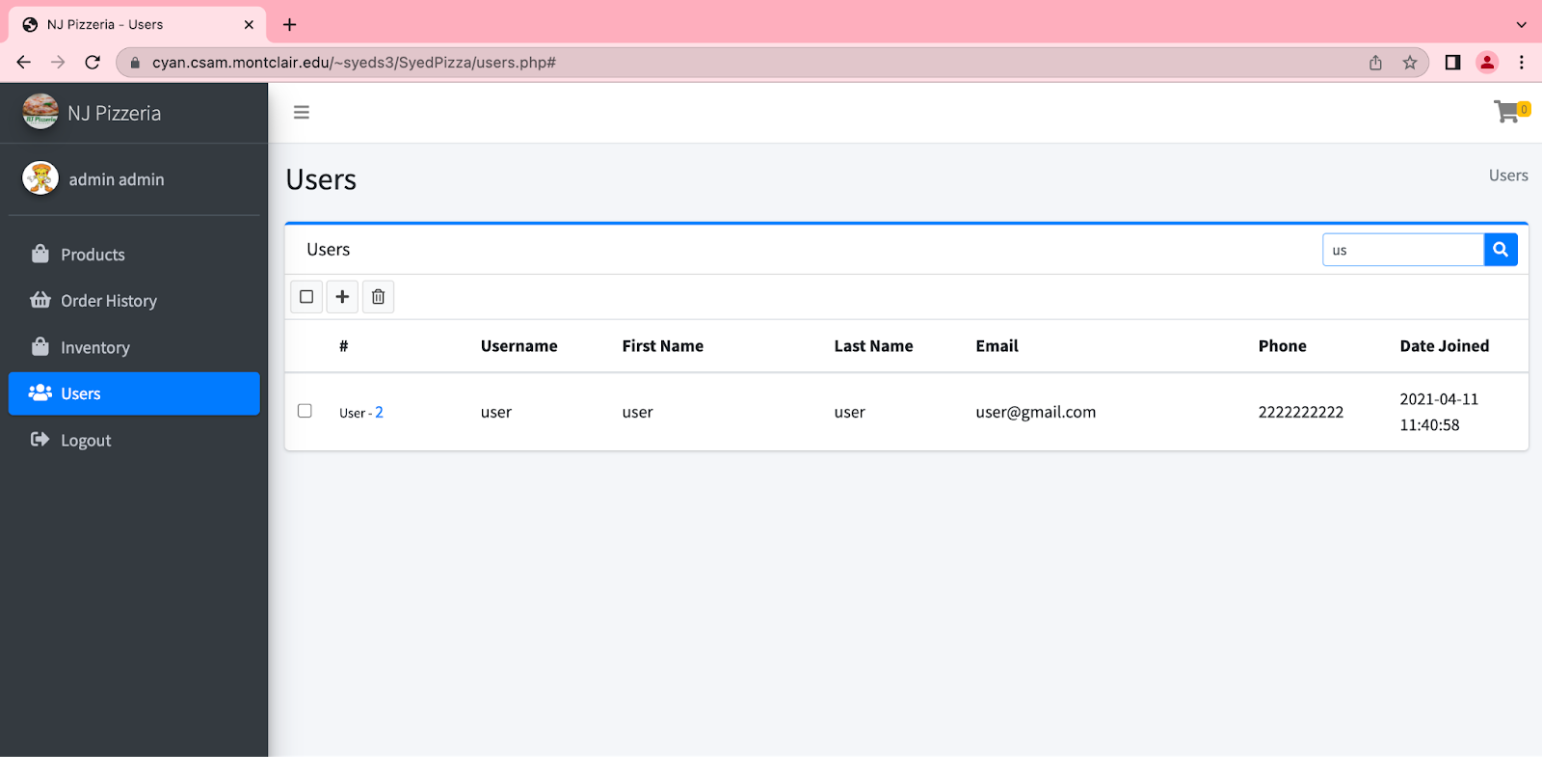

In Figure 31, the admin can search for users on the users’ page.

**JQuery statement for search interface**

$(function () {

$('#searchBar').on('keyup',function(){

var searchText = $(this).val();

var userTR = $('.userTR');

var userFirstName = $('.userFirstName');

var checkLength = userFirstName.length;

for(var i = 0; i < checkLength; i++)

{

if (!$(userFirstName[i]).text().toLowerCase().startsWith(searchText.toLowerCase())) {

$(userTR[i]).hide();

} else {

$(userTR[i]).show();

}

}

});

**Explanation**

The code is searching the users by their first name [16].

**The result of the search**

*Figure 32. User Search Results*



In Figure 32, the results of the search that the user made.

**JQuery statement for results of the search**

if (!$(userFirstName[i]).text().toLowerCase().startsWith(searchText.toLowerCase())) {

$(userTR[i]).hide();

} else {

$(userTR[i]).show();

}

}

**Explanation**

The code is going to show the results using a loop [16].

**Search**

**The actual search interface**

*Figure 33. Inventory Search* 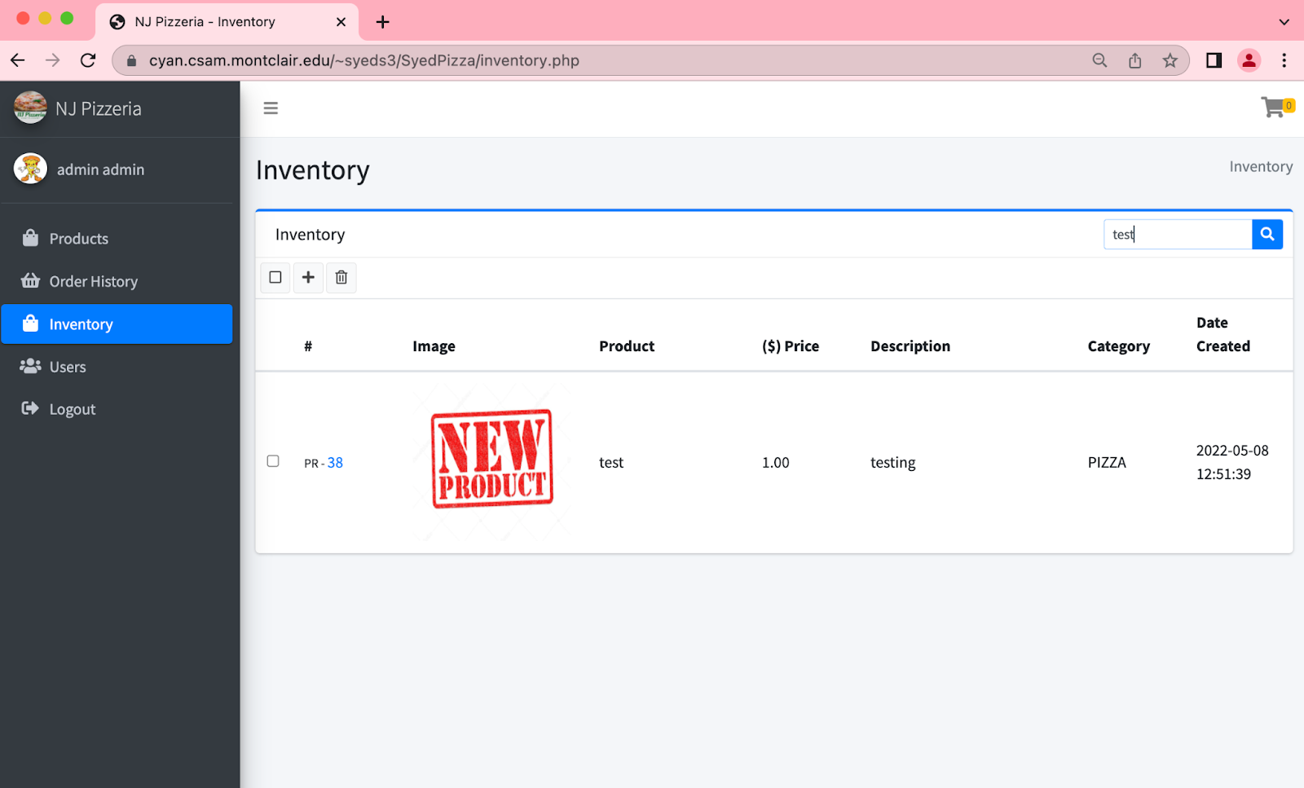

The user can search for products on the inventory page.

**JQuery statement for search interface**

$('#searchBar').on('keyup',function(){

var searchText = $(this).val();

var prodTR = $('.productTR');

var prodName = $('.prodName');

var checkLength = prodName.length;

for(var i = 0; i < checkLength; i++)

{

if (!$(prodName[i]).text().toLowerCase().startsWith(searchText.toLowerCase())) {

$(prodTR[i]).hide();

} else {

$(prodTR[i]).show();

}

}

});

**Explanation**

This search was easier to do because of the pervious searches I created in jQuery [16].

**The result of the search**

*Figure 34. Result of Inventory Search*



In Figure 34, the results of the search that the user made.

**JQuery statement for results of the search**

if (!$(prodName[i]).text().toLowerCase().startsWith(searchText.toLowerCase())) {

$(prodTR[i]).hide();

} else {

$(prodTR[i]).show();

}

}

**Explanation**

The loop will show the results of the query [16].

**The Environment of Each User**

**User**

The user’s environment of the project is able to login as user. The user can add products to their cart. The user is able to enter their address to get their items delivered. The user is able to search through the products. The user is able to see their pervious orders which then shows what they ordered and price. The user can update their own personal information.

**Admin**

The admin’s environment of the project is able to login as admin. The admin can add new products to the inventory. The admin is able to create an account for the user. The admin is able to view all the order history. The admin is able to search up users. The admin is able to modify their own information. The admin can also place an order same as the user.

**Database design**

**General Discussion**

I do not see any redundancy in Figure 2.All the data is reachable. I can make all the data joins if it needs to be. The attribute that would be specified as not null are the primary keys, unique keys, etc. In table cart the cartId, productId, quantity, userId, addedDate are all not null. In table categories the categorieId, name, description, dateadded are all not null. In deliverydetails table the id, orderId, deliveryname, deliveryPhoneNumber, deliveryTime, datetime are not null. In the ordersitems table the id, orderId, productId, quantity are all not null. In the orders table the orderId, userId, address, zipCode, phoneNumber, amount, orderDate are all not null. In the products table the productId, name, price, description, categorieId, img, madeDate are all not null. In users table, the id, username, firstName, lastName, email, phone, userType, password, joinDate are not null.

The times when null will occur is if the user wants to pick the order up then why would we need their address. The data will get into the tables by using php when the user enters their information into the website. The data can be modified in the database manually or the user can edit the information and that will update into the database.  No, I have normalization. For cart table, the primary key is cartId. For categories table, the primary key is categorieId. For deliverydetails table, the primary key is id and the unique key is orderId. For orderitems table, the primary key is id. For orders table, the primary key is orderId For product table, the primary key is productId. For users table, the primary key is id and the unique key is username.

**Second normal**

**CART**

|  |  |  |  |  |
| --- | --- | --- | --- | --- |
| **cartId** | **productId** | **quantity** | **userId** | **addedDate** |

**The cart table will use the user’s userId and the product’s productId.**

**CATEGORIES**

|  |  |  |  |
| --- | --- | --- | --- |
| **categorieId** | **name** | **description** | **dateadded** |

### **The categories table will categorize the products into their category.**

### **DELIVERYDETAILS**

|  |  |  |  |  |  |
| --- | --- | --- | --- | --- | --- |
| **id** | **orderId** | **deliveryname** | **deliveryPhoneNumber** | **deliveryTime** | **dateTime** |

## **The deliverydetails table will depend on the orderId.**

## **ORDERITEMS**

|  |  |  |  |
| --- | --- | --- | --- |
| **id** | **orderId** | **productId** | **quantity** |

### **The orderitems table will depend on the productId.**

## **ORDERS**

|  |  |  |  |  |  |  |  |  |
| --- | --- | --- | --- | --- | --- | --- | --- | --- |
| **orderId** | **userId** | **address** | **zipCode** | **phoneNumber** | **amount** | **payment** | **orderstatus** | **orderDate** |

### **The orders table is depending on userId.**

## **PRODUCT**

|  |  |  |  |  |  |  |
| --- | --- | --- | --- | --- | --- | --- |
| **productId** | **name** | **price** | **description** | **categorieId** | **img** | **madeDate** |

### **The product table is depending on categorieId.**

## **USERS**

|  |  |  |  |  |  |  |  |  |
| --- | --- | --- | --- | --- | --- | --- | --- | --- |
| **id** | **username** | **firstName** | **lastName** | **email** | **phone** | **userType** | **password** | **joinDate** |

### **The users table is depending on the userType.**

## **Third normal**

**CART**

|  |  |  |  |  |
| --- | --- | --- | --- | --- |
| **cartId** | **productId** | **quantity** | **userId** | **addedDate** |

### **This table depends on the whole key.**

## **CATEGORIES**

|  |  |  |  |
| --- | --- | --- | --- |
| **categorieId** | **name** | **description** | **dateadded** |

### **This table depends on the whole key.**

**DELIVERYDETAILS**

|  |  |  |  |  |  |
| --- | --- | --- | --- | --- | --- |
| **id** | **orderId** | **deliveryname** | **deliveryPhoneNumber** | **deliveryTime** | **dateTime** |

### **This table depends on the key.**

### **ORDERITEMS**

|  |  |  |  |
| --- | --- | --- | --- |
| **id** | **orderId** | **productId** | **quantity** |

## **This table depends on the whole key.**

## **ORDERS**

|  |  |  |  |  |  |  |  |  |
| --- | --- | --- | --- | --- | --- | --- | --- | --- |
| **orderId** | **userId** | **address** | **zipCode** | **phoneNumber** | **amount** | **payment** | **orderstatus** | **orderDate** |

### **This table depends on the whole key.**

## **PRODUCT**

|  |  |  |  |  |  |  |
| --- | --- | --- | --- | --- | --- | --- |
| **productId** | **name** | **price** | **description** | **categorieId** | **img** | **madeDate** |

### **This table depends on the whole key.**

## **USERS**

|  |  |  |  |  |  |  |  |  |
| --- | --- | --- | --- | --- | --- | --- | --- | --- |
| **id** | **username** | **firstName** | **lastName** | **email** | **phone** | **userType** | **password** | **joinDate** |

### **This table depends on the non prime key.**

**Test Plan**

To test the script was working I did go line by line which was very time consuming. I began looking up how to complete the work faster [17]. I tested all my queries on the website to check if the database was able to get the information correctly. I tested the cart multiple times because there were many issues with the cart first being that the quantity of the cart was not updating correctly. I had to add a new php file to make the quantity do what its supposed to. The adding of new user was very annoying to test because the database didn’t get the information correctly the first time [18]. The adding of a new product that the admin is able to do was giving an error because there was no image to call for a new product, so I added a trigger function to the database[19][20].

**Security**

Unfortunately, I did not have enough time to implement any security features. The login does not hash or encrypt any of the passwords. I did make sure that I implement some SQL injections throughout the project [. Also, I used post method instead of get [21].

**Results**

The result of this project is that most of the project is functional, but I should have spent more time doing the security implementation part of the project. The project creates an account for its users and stores the information into the database. Then, with the information the user used to create the account to log in to their account. The landing page displays the products of the site and shows the nav bar for easier access. The user is then able to add products to the cart. The cart will update with the products that the user selected. The users can also update the quantity of products in their cart. The user can checkout using their shipping information in the checkout and confirming the order with their password. The user can see their previous orders in their order history. The user can log out of the website. The challenges of the website is making the website functional with the database using PHP and mySQL. Further improve on the remove button, the security aspect, and doing the search in PHP. Also, I could have spent more time in adding more features to the admin portion. Final statement is that I tried my best to complete the work within a limited time.

**Appendix of code**

**Table of Content for Code**

index.php………………………………………………………………………………………………………………………………………...…47

inventory.php…………………………………………………………………………………………………………………………………….…47

cartitems.php………………………………………………………………………………………………………………………………………,,50

login.php……………………………………………………………………………………………………………………………………………53

orderhistory.php……………………………………………………………………………………………………………………………………55

orderitems.php…………………………………………………………………………………………………………………………………...…59

products.php……………………………………………………………………………………………………………………………………...…59

register.php…………………………………………………………………………………………………………………………………….……61

userprofile.php………………………………………………………………………………………………………………………………………62

users.php……………………………………………………………………………………………………………………………………….……63

Shared_Pages Folder………………………………………………………………………………………………………………………..………67

footer.php……………………………………………………………………………………………………………………………………………67

header.php…………………………………………………………………………………………………………………………….……..………68

navigation.php…………………………………………………………………………………………………………………………….…………68

FuctionsCode Folder…………………………………………………………………………………………………………………………………70

addProduct.php………………………………………………………………………………………………………………………………………70

addUser.php……………………………………………………………………………………………………………………………….…………70

dbCode.php……………………………………………………………………………………………………………………………..……………71

enum.php………………………………………………………………………………………………………………………………..……………75

loginCode.php………………………………………………………………………………………………………………………..………………75

logout.php……………………………………………………………………………………………………………………………………………75

mangeCartCode.php…………………………………………………………………………………………………………………………………75

placeOrder.php………………………………………………………………………………………………………………………………………77

registerCode.php…………………………………………………………………………………………………………..…………………………77

removeOrder.php………………………………………………………………………………………………………………….…………………78

removeProduct.php……………………………………………………………………………………………………………..……………………78

removeUser.php……………………………………………………………………………………………………………………………...………78

updateCartQuantity.php…………………………………………………………………………………………………………...…………………78

updateProfile.php……………………………………………………………………………………………………………………………………78

Database Dump…………………………………………………………………………………………………………………//………………….78

**Code**

**index.php**

<?php

include 'Shared_Pages/header.php';

?>

**inventory.php**

<?php

$title = "Inventory";

// include functions & files

include 'FunctionsCode/dbCode.php';

include 'Shared_Pages/header.php';

include 'Shared_Pages/navigation.php';

?>

<style>

.productImg{

width: 10em;

height: 10em;

}

</style>

<section class="content">

<div class="col-md-12">

<div class="card card-primary card-outline">

<div class="card-header">

<h3 class="card-title">Inventory</h3>

<div class="card-tools">

<div class="input-group input-group-sm">

<input type="text" id="searchBar" class="form-control" placeholder="Search Product By Name">

<div class="input-group-append">

<div class="btn btn-primary">

<i class="fas fa-search"></i>

</div>

</div>

</div>

</div>

<!-- /.card-tools -->

</div>

<!-- /.card-header -->

<div class="card-body p-0">

<div class="mailbox-controls">

<!-- Check all button -->

<button type="button" class="btn btn-default btn-sm checkbox-toggle"><i class="far fa-square"></i>

</button>

<button type="button" class="btn btn-default btn-sm" data-toggle="modal" data-target="#AddProduct">

<i class="fa fa-plus"></i>

</button>

<button type="button" id="deleteBTN" class="btn btn-default btn-sm">

<i class="far fa-trash-alt"></i>

</button>

</div>

<!-- /.btn-group -->

</div>

<div class="table-responsive mailbox-messages">

<table class="table table-striped projects">

<thead>

<tr>

<th style="width: 1%"></th>

<th style="width: 10%">

#

</th>

<th style="width: 10%">

Image

</th>

<th style="width: 15%">

Product

</th>

<th style="width: 10%">

($) Price

</th>

<th style="width: 20%">

Description

</th>

<th style="width: 10%">

Category

</th>

<th style="width: 10%">

Date Created

</th>

</tr>

</thead>

<tbody>

<tr>

<?php

$sql = "SELECT * FROM `product`";

$result = mysqli_query($conn, $sql);

$counter = 0;

while($row = mysqli_fetch_assoc($result)){

$productId = $row['productId'];

$name = $row['name'];

$price = $row['price'];

$description = $row['description'];

$category = $row['categorieId'];

$dateCreated = $row['madeDate'];

$category = getCategoryName($category);

echo '<tr class="productTR">

<td><div class="icheck-primary"><input type="checkbox" value="" name="ProductCheckbox"><label for="ProductCheckbox"></label></div></td>

<td><small>PR - </small><a href="#" class="prodIDA">' . $productId . '</a></td>

<td><img src="dist/img/'. $row['img'] .'" alt="Product Image Here" class = "productImg" /></td>

<td class="prodName">' . $name . '</td>

<td>' . $price . '</td>

<td>' . $description . '</td>

<td>' . $category['name'] . '</td>

<td><span>' . $dateCreated. '</span></td>

</tr>';

$counter++;

}

if($counter==0) {

?>

<td colspan="8">

<div class="col-md-12 my-5"><div class="card"> <div class="card-body cart"><div class="col-sm-12 empty-cart-cls text-center"> <img src="https://i.imgur.com/dCdflKN.png" width="130" height="130" class="img-fluid mb-4 mr-3"><h3><strong>There are no Products.</strong></h3><h4>Press <bold>"+" </bold> button to add product.</h4></div></div></div></div>

</td>

<?php

}

?>

</tr>

</tbody>

</table>

<!-- /.table -->

</div>

<!-- /.mail-box-messages -->

</div>

<!-- /.card-body -->

</div>

<!-- /.card -->

</section>

<!-- /.Add Product -->

<div class="modal fade" id="AddProduct" tabindex="-1" role="dialog" aria-labelledby="AddProduct" aria-hidden="false">

<div class="modal-dialog modal-dialog-centered" role="document">

<div class="modal-content">

<div class="modal-header">

<h5 class="modal-title" id="checkout">Enter Product Details:</h5>

<button type="button" class="close" data-dismiss="modal" aria-label="Close">

<span aria-hidden="true">&times;</span>

</button>

</div>

<div class="modal-body">

<form action="FunctionsCode/addProduct.php" method="post">

<div class="form-group">

<b><label for="prodName">Product Name:</label></b>

<input class="form-control" id="prodName" name="prodName" placeholder="Product Name" type="text" required minlength="3" maxlength="500">

</div>

<div class="form-row">

<div class="form-group col-md-6 mb-0">

<b><label for="price">Price:</label></b>

<div class="input-group mb-3">

<div class="input-group-prepend">

<span class="input-group-text" id="basic-addon">$</span>

</div>

<input type="number" class="form-control" id="price" name="price" placeholder="0" required maxlength="2">

</div>

</div>

<div class="form-group col-md-6 mb-0">

<b><label for="category">Category:</label></b>

<select name="category" id="category" class="form-control" required>

<option value="0">Please Select Category</option>

<?php

$allCategories = getAllCategories();

while ($row = $allCategories->fetch_assoc()) {

?>

<option value="<?= $row['categorieId']?>"><?= $row['name']?></option>

<?php

}

?>

</select>

</div>

</div>

<div class="form-group">

<b><label for="description">Description:</label></b>

<textarea class="form-control" id="description" name="description" placeholder="Description">

</textarea>

</div>

<div class="modal-footer">

<button type="button" class="btn btn-info" data-dismiss="modal">Cancel</button>

<button type="submit" name="Add" class="btn btn-success">Add Product</button>

</div>

</form>

</div>

</div>

</div>

</div>

<!-- jQuery -->

<script src="plugins/jquery/jquery.min.js"></script>

<script>

$(function () {

$('#searchBar').on('keyup',function(){

var searchText = $(this).val();

var prodTR = $('.productTR');

var prodName = $('.prodName');

var checkLength = prodName.length;

for(var i = 0; i < checkLength; i++)

{

if (!$(prodName[i]).text().toLowerCase().startsWith(searchText.toLowerCase())) {

$(prodTR[i]).hide();

} else {

$(prodTR[i]).show();

}

}

});

$('#deleteBTN').on('click',function(){

var checkboxes = $('.mailbox-messages input[type=\'checkbox\']').filter(':checked');

var isLastCall = false;

for(var i = 0; i < checkboxes.length ; i++)

{

var prodIDA = $(checkboxes[i]).parent().parent().parent().find('.prodIDA');

if(i+1 === checkboxes.length)

isLastCall = true;

AJAXCallToPHP($(prodIDA).text(),isLastCall);

}

});

function AJAXCallToPHP($prodID, isLastCall)

{

var URL = window.location.origin + '/SyedPizza/FunctionsCode/removeProduct.php';

$.ajax({

url: URL,

type:'POST',

async:false,

data:{$prodID:$prodID},

success: function(result){

if(result === 'True' && isLastCall){

window.location.reload();

}

},

error: function(result){

debugger;

}

});

}

//Enable check and uncheck all functionality

$('.checkbox-toggle').click(function () {

var clicks = $(this).data('clicks')

if (clicks) {

//Uncheck all checkboxes

$('.mailbox-messages input[type=\'checkbox\']').prop('checked', false)

$('.checkbox-toggle .far.fa-check-square').removeClass('fa-check-square').addClass('fa-square')

} else {

//Check all checkboxes

$('.mailbox-messages input[type=\'checkbox\']').prop('checked', true)

$('.checkbox-toggle .far.fa-square').removeClass('fa-square').addClass('fa-check-square')

}

$(this).data('clicks', !clicks)

});

});

</script>

<!-- footer -->

<?php include 'Shared_Pages/footer.php';?>

**cartitems.php**

<?php

$title = "Cart";

// include functions & files

include 'FunctionsCode/dbCode.php';

include 'Shared_Pages/header.php';

include 'Shared_Pages/navigation.php';

?>

<style>

.productImg{

width: 10em;

height: 10em;

}

</style>

<!-- Main content -->

<section class="content">

<!-- Default box -->

<div class="card">

<div class="card-header col-md-12">

<div class="col-md-8">

<h3 class="card-title">Cart Items</h3>

</div>

<?php

$allCartItems = getCartItemsForUser($_SESSION['userID']);

$num_results = $allCartItems->num_rows;

if ($num_results != 0) {

?>

<div class="col-md-6 float-sm-right">

<button type="button" class="btn btn-block btn-warning float-sm-right col-md-4" data-toggle="modal" data-target="#checkout">Proceed to checkout</button>

</div>

<?php

}

else

{

?>

<div class="col-md-6 float-sm-right">

<button type="button" class="btn btn-block btn-warning float-sm-right col-md-4" data-toggle="modal" data-target="#checkout" disabled>Proceed to checkout</button>

</div>

<?php

}

?>

</div>

<div class="card-body p-0">

<table class="table table-striped projects">

<thead>

<tr>

<th style="width: 1%">

#

</th>

<th style="width: 15%">

Image

</th>

<th style="width: 15%">

Product

</th>

<th style="width: 10%">

($) Price

</th>

<th style="width: 10%">

Quantity

</th>

<th style="width: 20%">

Description

</th>

<th style="width: 10%">

Added Date

</th>

<th style="width: 20%">

</th>

</tr>

</thead>

<tbody>

<?php

if ($num_results != 0) {

$i = 1;

$totalPrice = 0;

$totalQuantity = 0;

while ($row = $allCartItems->fetch_assoc()) {

echo '<tr>';

echo '<td>';

echo $i;

$product = getSingleProduct($row['productId']);

$category = getCategoryName($product['categorieId']);

echo '</td>';

echo '<td>';

echo '<img src="dist/img/'. $product['img'] .'" alt="Product Image Here" class = "productImg" />';

echo '</td>';

echo '<td>';

echo '<a>'. $product['name'] .' </a> <br/> <small> Category: '. $category['name'] .' </small> ';

echo '</td>';

echo '<td>';

$totalQuantity = $totalQuantity + intval($row['quantity']);

$totalPrice = $totalPrice + (intval($product['price']) * intval($row['quantity']));

echo '<span>$'. $product['price'] .'</span>';

echo '</td>';

echo '<td>';

echo '<form name="quanForm" action="FunctionsCode/updateCartQuantity.php" method = "POST">';

echo '<input type="number" name="quantity" onkeyup="updateCartQuantity(this)" onmouseup="updateCartQuantity(this)" value="'. $row['quantity'] .'" min="1" class="form-control"/>';

echo '<input type="hidden" name="cartID" value="'. $row['cartId'] .'"/>';

echo '<button type="submit" name="updateQuan" hidden></button>';

echo '</form>';

echo '</td>';

echo '<td>';

echo '<span>'. $product['description'] .'</span>';

echo '</td>';

echo '<td>';

echo '<span>'. DateTime::createFromFormat("Y-m-d H:i:s",$row['addedDate'])->format("m/d/Y") .'</span>';

echo '</td>';

echo '<td class="project-actions">';

echo '<form action="FunctionsCode/manageCartCode.php" method="POST">';

echo '<input type="hidden" name="itemId" value="'.$row['productId']. '">';

echo '<button type="submit" name="removeItem" class="btn btn-danger col-md-8">';

echo '<i class="fas fa-trash"> </i>';

echo ' Remove</button>';

echo '</form>';

echo '</td>';

echo '</tr>';

$i++;

}

}

else

{

?>

<td colspan="8">

<div class="col-md-12 my-5"><div class="card"> <div class="card-body cart"><div class="col-sm-12 empty-cart-cls text-center"> <img src="https://i.imgur.com/dCdflKN.png" width="130" height="130" class="img-fluid mb-4 mr-3"><h3><strong>No Cart Items.</strong></h3><h4>Keep Shoping To Add Products To Cart.</h4></div></div></div></div>

</td>

<?php

}

?>

</tbody>

<tfoot>

<tr>

<th style="width: 1%">

</th>

<th style="width: 15%">

</th>

<th style="width: 15%">

</th>

<th style="width: 10%">

<?php

if ($num_results != 0) {

echo 'Total Price: $'. $totalPrice .' ' ;

}

?>

</th>

<th style="width: 11%">

<?php

if ($num_results != 0) {

echo 'Total Quantity: '. $totalQuantity .' ' ;

}

?>

</th>

<th style="width: 20%">

</th>

<th style="width: 10%">

</th>

<th style="width: 20%">

</th>

</tr>

</tfoot>

</table>

</div>

<!-- /.card-body -->

</div>

<!-- /.card -->

<!-- Checkout -->

<div class="modal fade" id="checkout" tabindex="-1" role="dialog" aria-labelledby="checkout" aria-hidden="false">

<div class="modal-dialog modal-dialog-centered" role="document">

<div class="modal-content">

<div class="modal-header">

<h5 class="modal-title" id="checkout">Enter Your Details:</h5>

<button type="button" class="close" data-dismiss="modal" aria-label="Close">

<span aria-hidden="true">&times;</span>

</button>

</div>

<div class="modal-body">

<form action="FunctionsCode/placeOrder.php" method="post">

<div class="form-group">

<b><label for="address">Address:</label></b>

<input class="form-control" id="address" name="address" placeholder="Address" type="text" required minlength="3" maxlength="500">

</div>

<div class="form-row">

<div class="form-group col-md-6 mb-0">

<b><label for="phone">Phone Number:</label></b>

<div class="input-group mb-3">

<div class="input-group-prepend">

<span class="input-group-text" id="basic-addon">+1</span>

</div>

<input type="tel" class="form-control" id="phone" name="phone" placeholder="xxxxxxxxxx" required pattern="[0-9]{10}" maxlength="10">

</div>

</div>

<div class="form-group col-md-6 mb-0">

<b><label for="zipcode">Zip Code:</label></b>

<input type="text" class="form-control" id="zipcode" name="zipcode" placeholder="xxxxxx" required pattern="[0-9]{6}" maxlength="6">

</div>

</div>

<div class="form-group">

<b><label for="password">Password:</label></b>

<input class="form-control" id="password" name="password" placeholder="Password" type="password" required minlength="4" maxlength="21" data-toggle="password">

</div>

<div class="modal-footer">

<button type="button" class="btn btn-info" data-dismiss="modal">Cancel</button>

<input type="hidden" name="amount" value="<?php echo $totalPrice ?>">

<button type="submit" name="checkout" class="btn btn-success">Place Order</button>

</div>

</form>

</div>

</div>

</div>

</div>

</section>

<!-- footer -->

<?php include 'Shared_Pages/footer.php';?>

**login.php**

<!DOCTYPE html>

<html lang="en">

<head>

<meta charset="utf-8">

<meta name="viewport" content="width=device-width, initial-scale=1">

<title>NJ Pizzeria</title>

<!-- Google Font: Source Sans Pro -->

<link rel="stylesheet" href="https://fonts.googleapis.com/css?family=Source+Sans+Pro:300,400,400i,700&display=fallback">

<!-- Font Awesome Icons -->

<link rel="stylesheet" href="plugins/fontawesome-free/css/all.min.css">

<!-- overlayScrollbars -->

<link rel="stylesheet" href="plugins/overlayScrollbars/css/OverlayScrollbars.min.css">

<!-- BS Stepper -->

<link rel="stylesheet" href="plugins/bs-stepper/css/bs-stepper.min.css">

<!-- Theme style -->

<link rel="stylesheet" href="dist/css/adminlte.min.css">

</head>

<body class="hold-transition login-page">

<div class="login-box hidden">

<!-- /.login-logo -->

<div class="card card-outline card-primary">

<div class="card-header text-center">

<a href="login.php" class="h1"><b>NJ</b>Pizzeria</a>

</div>

<div class="card-body">

<p class="login-box-msg">Sign in to start your session</p>

<div class="card-body p-0">

<div class="bs-stepper">

<div class="bs-stepper-header" role="tablist">

<!-- your steps here -->

<div class="step" data-target="#email-part">

<button type="button" class="step-trigger" role="tab" aria-controls="logins-part" id="logins-part-trigger">

<span class="bs-stepper-circle">1</span>

<span class="bs-stepper-label">Email</span>

</button>

</div>

<div class="step" data-target="#password-part">

<button type="button" class="step-trigger" role="tab" aria-controls="information-part" id="information-part-trigger">

<span class="bs-stepper-circle">2</span>

<span class="bs-stepper-label">Password</span>

</button>

</div>

</div>

<div class="bs-stepper-content">

<!-- your steps content here -->

<form action="FunctionsCode/loginCode.php" method="post">

<div id="email-part" class="content" role="tabpanel" aria-labelledby="logins-part-trigger">

<div class="input-group mb-3">

<input type="text" id="username" name="username" class="form-control" placeholder="Username">

<div class="input-group-append">

<div class="input-group-text">

<span class="fas fa-envelope"></span>

</div>

</div>

</div>

<button class="btn btn-info btn-block" id="nxtBtn" type="button" onclick="stepper.next()">Next</button>

<div class="row">

<span>&nbsp;</span>

</div>

<div class="row">

<span>&nbsp;</span>

</div>

</div>

<div id="password-part" class="content" role="tabpanel" aria-labelledby="information-part-trigger">

<div class="input-group mb-3">

<input type="password" name="pwd" id="pwd" class="form-control" placeholder="Password">

<div class="input-group-append">

<div class="input-group-text">

<span class="fas fa-lock"></span>

</div>

</div>

</div>

<button class="btn btn-info btn-block" type="button" onclick="stepper.previous()">Previous</button>

<button type="submit" class="btn btn-success btn-block">Login</button>

</div>

<div class="row">

<span>&nbsp;</span>

</div>

</form>

</div>

</div>

</div>

<!-- /.card-body -->

<div class="card-footer">

<a href="register.php" class="text-center">Register a new membership</a>

</div>

</div>

<!-- /.card-body -->

</div>

<!-- /.card -->

</div>

<!-- /.login-box -->

<!-- jQuery -->

<script src="plugins/jquery/jquery.min.js"></script>

<script src="plugins/bs-stepper/js/bs-stepper.min.js"></script>

<script>

// BS-Stepper Init

document.addEventListener('DOMContentLoaded', function () {

window.stepper = new Stepper(document.querySelector('.bs-stepper'))

})

$('#username').keypress(function(event){

var keycode = (event.keyCode ? event.keyCode : event.which);

if(keycode == '13'){

event.preventDefault();

}

});

</script>

<?php

include 'Shared_Pages/footer.php';

?>

**orderhistory.php**

<?php

$title = "Order History";

// include functions & files

include 'FunctionsCode/dbCode.php';

include 'Shared_Pages/header.php';

include 'Shared_Pages/navigation.php';

?>

<section class="content">

<div class="col-md-12">

<div class="card card-primary card-outline">

<div class="card-header">

<h3 class="card-title">Order History</h3>

<div class="card-tools">

<div class="input-group input-group-sm">

<input type="text" id="searchBar" class="form-control" placeholder="Search Orders By ID">

<div class="input-group-append">

<div class="btn btn-primary">

<i class="fas fa-search"></i>

</div>

</div>

</div> </div>

<!-- /.card-tools -->

</div>

<!-- /.card-header -->

<div class="card-body p-0">

<div class="mailbox-controls">

<!-- Check all button -->

<button type="button" class="btn btn-default btn-sm checkbox-toggle"><i class="far fa-square"></i>

</button>

<button type="button" id="deleteBTN" class="btn btn-default btn-sm">

<i class="far fa-trash-alt"></i>

</button>

</div>

<!-- /.btn-group -->

</div>

<div class="table-responsive mailbox-messages">

<table class="table table-hover table-striped">

<thead>

<tr>

<th></th>

<th>Order Id</th>

<th>Address</th>

<th>Phone Number</th>

<th>Amount</th>

<th>Payment Mode</th>

<th>Order Date</th>

<th>Status</th>

<th>Items</th>

</tr>

</thead>

<tbody>

<tr>

<?php

$userId = $_SESSION['userID'];

$sql = "SELECT * FROM `orders` WHERE `userId`= $userId";

$result = mysqli_query($conn, $sql);

$counter = 0;

while($row = mysqli_fetch_assoc($result)){

$orderId = $row['orderId'];

$address = $row['address'];

$zipCode = $row['zipCode'];

$phoneNumber = $row['phoneNumber'];

$amount = $row['amount'];

$orderDate = $row['orderDate'];

$payment = $row['payment'];

if($payment == 0) {

$payment = "Cash on Delivery";

}

else {

$payment = "Online";

}

$orderStatus = OrderStatus(intval($row['orderStatus']));

$sqlItems = "SELECT * FROM `orderitems` WHERE `orderId`= $orderId";

$resultItems = mysqli_query($conn, $sqlItems);

$totalItems = $resultItems->num_rows;

$counter++;

echo '<tr class="orderTR">

<td><div class="icheck-primary"><input type="checkbox" value="" name="OrderCheckbox"><label for="OrderCheckbox"></label></div></td>

<td><small>OR - </small><a href="orderitems.php?orderID='. $orderId .'" class="orderIDA">' . $orderId . '</a></td>

<td>' . substr($address, 0, 20) . '...</td>

<td>' . $phoneNumber . '</td>

<td>' . $amount . '</td>

<td>' . $payment . '</td>

<td>' . $orderDate . '</td>

<td><span>' . OrderStatus($orderStatus) . '</span></td>

<td><span>' . $totalItems . ' </span></td>

</tr>';

}

if($counter==0) {

?><script> document.getElementById("empty").innerHTML = '<div class="col-md-12 my-5"><div class="card"> <div class="card-body cart"><div class="col-sm-12 empty-cart-cls text-center"> <img src="https://i.imgur.com/dCdflKN.png" width="130" height="130" class="img-fluid mb-4 mr-3"><h3><strong>You have not ordered any items.</strong></h3><h4>Keep Shopping...</h4> <a href="index.php" class="btn btn-primary cart-btn-transform m-3" data-abc="true">Continue shopping</a></div></div></div></div>';</script> <?ph>

}

?>

</tr>

</tbody>

</table>

<!-- /.table -->

</div>

<!-- /.mail-box-messages -->

</div>

<!-- /.card-body -->

<!-- /.card -->

</div>

</section>

<!-- jQuery -->

<script src="plugins/jquery/jquery.min.js"></script>

<script>

$(function () {

$('#searchBar').on('keyup',function(){

var searchText = $(this).val();

var orderTR = $('.orderTR');

var orderIDA = $('.orderIDA');

var checkLength = orderIDA.length;

for(var i = 0; i < checkLength; i++)

{

if (!$(orderIDA[i]).text().toLowerCase().startsWith(searchText.toLowerCase())) {

$(orderTR[i]).hide();

} else {

$(orderTR[i]).show();

}

}

});

$('#deleteBTN').on('click',function(){

var checkboxes = $('.mailbox-messages input[type=\'checkbox\']').filter(':checked');

var isLastCall = false;

for(var i = 0; i < checkboxes.length ; i++)

{

if($(checkboxes[i]).prop('checked')===true)

{

var orderIDA = $(checkboxes[i]).parent().parent().parent().find('.orderIDA');

if(i+1 === checkboxes.length)

isLastCall = true;

AJAXCallToPHP($(orderIDA[i]).text(),isLastCall);

}

}

});

function AJAXCallToPHP($orderID, $isLastCall)

{

var URL = window.location.origin + '/SyedPizza/FunctionsCode/removeOrder.php';

$.ajax({

url: URL,

type:'POST',

async:false,

data:{orderID:$orderID},

success: function(result){

if(result === 'True' && $isLastCall){

window.location.reload();

}

},

error: function(result){

debugger;

}

});

}

//Enable check and uncheck all functionality

$('.checkbox-toggle').click(function () {

var clicks = $(this).data('clicks')

if (clicks) {

//Uncheck all checkboxes

$('.mailbox-messages input[type=\'checkbox\']').prop('checked', false)

$('.checkbox-toggle .far.fa-check-square').removeClass('fa-check-square').addClass('fa-square')

} else {

//Check all checkboxes

$('.mailbox-messages input[type=\'checkbox\']').prop('checked', true)

$('.checkbox-toggle .far.fa-square').removeClass('fa-square').addClass('fa-check-square')

}

$(this).data('clicks', !clicks)

});

});

</script>

<!-- footer -->

<?php include 'Shared_Pages/footer.php';?>

**orderitems.php**

<?php

$title = "Order History";

// include functions & files

include 'FunctionsCode/dbCode.php';

include 'Shared_Pages/header.php';

include 'Shared_Pages/navigation.php';

?>

<style>

.productImg{

width: 10em;

height: 10em;

}

</style>

<section class="content">

<div class="col-md-12">

<div class="card card-primary card-outline">

<!-- /.card-header -->

<div class="card-body p-0">

<table class="table table-striped projects">

<thead>

<tr>

<th style="width: 1%">

#

</th>

<th style="width: 15%">

Image

</th>

<th style="width: 15%">

Product

</th>

<th style="width: 10%">

($) Price

</th>

<th style="width: 10%">

Quantity

</th>

<th style="width: 20%">

Description

</th>

</tr>

</thead>

<tbody>

<?php

$orderID = $_GET['orderID'];

$orderItems = getOrderItemsForOrder($orderID);

$num_results = $orderItems->num_rows;

if ($num_results != 0) {

$i = 1;

$totalPrice = 0;

$totalQuantity = 0;

while ($row = $orderItems->fetch_assoc()) {

echo '<tr>';

echo '<td>';

echo $i;

$product = getSingleProduct($row['productId']);

$category = getCategoryName($product['categorieId']);

echo '</td>';

echo '<td>';

echo '<img src="dist/img/'. $product['img'] .'" alt="Product Image Here" class = "productImg" />';

echo '</td>';

echo '<td>';

echo '<a>'. $product['name'] .' </a> <br/> <small> Category: '. $category['name'] .' </small> ';

echo '</td>';

echo '<td>';

$totalQuantity = $totalQuantity + intval($row['quantity']);

$totalPrice = $totalPrice + (intval($product['price']) * intval($row['quantity']));

echo '<span>$'. $product['price'] .'</span>';

echo '</td>';

echo '<td>';

echo '<input type="number" value="'. $row['quantity'] .'" min="1" disabled class="form-control"/>';

echo '</td>';

echo '<td>';

echo '<span>'. $product['description'] .'</span>';

echo '</td>';

echo '</tr>';

$i++;

}

}

?>

</tbody>

</table>

</div>

<!-- /.mail-box-messages -->

</div>

<!-- /.card-body -->

</div>

<!-- /.card -->

</section>

<!-- footer -->

<?php include 'Shared_Pages/footer.php';?>

**products.php**

<?php

$title = "Products";

// include functions & files

include 'FunctionsCode/dbCode.php';

include 'Shared_Pages/header.php';

include 'Shared_Pages/navigation.php';

?>

<style>

.productImg{

width: 50em;

height: 20em;

}

</style>

<!-- Main content -->

<section class="content">

<div class="container-fluid">

<div class="row">

<div class="col-12">

<div class="card card-info">

<div class="card-body">

<div class="row">

<div class="col-md-12">

<div class="card">

<form id="SearchForm" action="transactions-by-name.php" method="post">

<div class="input-group">

<input type="search" id="searchedProduct" class="form-control form-control-lg" placeholder="Search By Product Name">

<div class="input-group-append">

<button type="button" class="btn btn-lg btn-default">

<i class="fa fa-search"></i>

</button>

</div>

</div>

</form>

</div>

</div>

</div>

<div>

<div class="btn-group w-100 mb-2">

<a class="btn btn-info active allItemsATag" href="javascript:void(0)" data-filter="all"> All items </a>

<?php

$categories = getAllCategories();

$num_results = $categories->num_rows;

if ($num_results != 0) {

while ($row = $categories->fetch_assoc()) {

echo '<a class="btn btn-info" href="javascript:void(0)" data-filter="' . $row['categorieId'] . '">' . $row['name'] . '</a>';

}

}

?>

</div>

</div>

<div>

<div class="filter-container p-0 row">

<?php

$products = getAllProducts();

$num_results = $products->num_rows;

if ($num_results != 0) {

while ($row = $products->fetch_assoc()) {

echo '<div class="filtr-item col-sm-3 divProducts" data-category="'. $row['categorieId'] .'" data-sort="white sample">';

echo '<a class="btn btn-info" href="dist/img/'. $row['img'] .'" data-toggle="lightbox" data-img="'. $row['img'] .'" data-footer="'. $row['description'] .'" data-title="'. $row['name'] .' - $'. $row['price'] .'">';

echo '<img src="dist/img/'. $row['img'] .'" class="img-fluid mb-2 productImg" alt="'. $row['name'] .' - $'. $row['price'] .'"/>';

echo '<span class = "productNameSpan"> '. $row['name'] .' </span> ';

echo '</a>';

echo '<form action="FunctionsCode/manageCartCode.php" method="POST">';

echo '<input type="hidden" name="itemId" value="'.$row['productId']. '">';

$numExistRows = checkCartItemForUser($row['productId'],$_SESSION['userID']);

if($numExistRows > 0){

echo '<button type="submit" name="removeItem" class="btn btn-danger col-md-12">Remove From Cart</button>';

}

else{

echo '<button type="submit" name="addToCart" class="btn btn-warning col-md-12">Add To Cart</button>';

}

echo '</form>';

echo '</div>';

}

}

?>

</div>

</div>

</div>

</div>

</div>

</div>

</div>

<!-- /.container-fluid -->

</section>

<!-- /.content -->

<!-- jQuery -->

<script src="plugins/jquery/jquery.min.js"></script>

<!-- Ekko Lightbox -->

<script src="plugins/ekko-lightbox/ekko-lightbox.min.js"></script>

<!-- Filterizr-->

<script src="plugins/filterizr/jquery.filterizr.min.js"></script>

<script>

$('#searchedProduct').on('keyup',function();

var searchValue = $(this).val();

var spanProducts = $('.productNameSpan');

var divProducts = $('.divProducts');

var checkLength = spanProducts.length;

for(var i = 0; i < checkLength; i++)

{

var productName = $.trim($(spanProducts[i]).text());

if (!productName.toLowerCase().startsWith(searchValue.toLowerCase())) {

$(divProducts[i]).hide();

} else {

$(divProducts[i]).show();

}

}

});

$(function () {

$(document).on('click', '[data-toggle="lightbox"]', function(event) {

event.preventDefault();

$(this).ekkoLightbox({

alwaysShowClose: true

});

});

$('.filter-container').filterizr({gutterPixels: 3});

$('.btn[data-filter]').on('click', function() {

$('.btn[data-filter]').removeClass('active');

$(this).addClass('active');

});

})

</script>

<!-- footer -->

<?php include 'Shared_Pages/footer.php'; ?>

**register.php**

<!DOCTYPE html>

<html lang="en">

<head>

<meta charset="utf-8">

<meta name="viewport" content="width=device-width, initial-scale=1">

<title>NJ Pizzeria</title>

<!-- Google Font: Source Sans Pro -->

<link rel="stylesheet" href="https://fonts.googleapis.com/css?family=Source+Sans+Pro:300,400,400i,700&display=fallback">

<!-- Font Awesome Icons -->

<link rel="stylesheet" href="plugins/fontawesome-free/css/all.min.css">

<!-- overlayScrollbars -->

<link rel="stylesheet" href="plugins/overlayScrollbars/css/OverlayScrollbars.min.css">

<!-- BS Stepper -->

<link rel="stylesheet" href="plugins/bs-stepper/css/bs-stepper.min.css">

<!-- Theme style -->

<link rel="stylesheet" href="dist/css/adminlte.min.css">

</head>

<body class="hold-transition register-page">

<div class="register-box">

<div class="card card-outline card-primary">

<div class="card-header text-center">

<a href="register.php" class="h1"><b>NJ</b>Pizzeria</a>

</div>

<div class="card-body">

<p class="login-box-msg">Register a new membership</p>

<form action="FunctionsCode/registerCode.php" method="post" oninput='confirmPass.setCustomValidity(confirmPass.value != pass.value ? "Passwords do not match." : "")'>

<div class="input-group mb-3">

<input type="text" class="form-control" name="firstName" required id="firstName" placeholder="First name">

<div class="input-group-append">

<div class="input-group-text">

<span class="fas fa-user"></span>

</div>

</div>

</div>

<div class="input-group mb-3">

<input type="text" class="form-control" name="lastName" required id="lastName" placeholder="Last name">

<div class="input-group-append">

<div class="input-group-text">

<span class="fas fa-user"></span>

</div>

</div>

</div>

<div class="input-group mb-3">

<input type="text" class="form-control" name="username" required id="username" placeholder="Username">

<div class="input-group-append">

<div class="input-group-text">

<span class="fas fa-user"></span>

</div>

</div>

</div>

<div class="input-group mb-3">

<input type="number" class="form-control" name="phnNum" required id="phnNum" placeholder="Phone Number">

<div class="input-group-append">

<div class="input-group-text">

<span class="fas fa-phone"></span>

</div>

</div>

</div>

<div class="input-group mb-3">

<input type="email" class="form-control" name="email" required id="email" placeholder="Email">

<div class="input-group-append">

<div class="input-group-text">

<span class="fas fa-envelope"></span>

</div>

</div>

</div>

<div class="input-group mb-3">

<input type="password" class="form-control" name="pass" required id="pass" placeholder="Password">

<div class="input-group-append">

<div class="input-group-text">

<span class="fas fa-lock"></span>

</div>

</div>

</div>

<div class="input-group mb-3">

<input type="password" class="form-control" name="confirmPass" required id="confirmPass" placeholder="Retype password">

<div class="input-group-append">

<div class="input-group-text">

<span class="fas fa-lock"></span>

</div>

</div>

</div>

<div class="row">

<!-- /.col -->

<div class="col-md-12">

<button type="submit" class="btn btn-info btn-block">Register</button>

<div class="row">

<span>&nbsp;</span>

</div>

</div>

<!-- /.col -->

</div>

</form>

<div class="card-footer">

<a href="login.php" class="text-center">Already have an account</a>

</div>

</div>

<!-- /.form-box -->

</div><!-- /.card -->

</div>

<!-- /.register-box -->

<?php

include 'Shared_Pages/footer.php';

?>

**userprofile.php**

<?php

$title = "Edit Account";

include 'FunctionsCode/dbCode.php';

include 'Shared_Pages/header.php';

include 'Shared_Pages/navigation.php';

$data = getUserProfileData($_SESSION['userID']);

?>

<!-- Main content -->

<section class="content">

<div class="container-fluid">

<div class="row">

<div class="col-md-6">

<div class="card card-primary">

<div class="card-header">

<h3 class="card-title">Personal Info</h3>

</div>

<div class="card-body">

<form action="FunctionsCode/updateProfile.php" method="post">

<div class="form-group">

<label for="fname">First Name</label>

<input type="text" name="fname" id="fname" value="<?php echo $data['firstName']; ?>" class="form-control" maxlength="30" required />

</div>

<div class="form-group">

<label for="lname">Last Name</label>

<input type="text" name="lname" id="lname" value="<?php echo $data['lastName']; ?>" class=" form-control" maxlength="30" required />

</div>

<div class="form-group">

<label for="uname">Username</label>

<input type="text" name="uname" id="uname" value="<?php echo $data['username']; ?>" class=" form-control" maxlength="20" required />

</div>

<div class="form-group">

<label for="email">Email Address</label>

<input type="email" name="email" id="email" value="<?php echo $data['email']; ?>" class=" form-control" maxlength="60" required />

</div>

<div class="form-group">

<label for="phone">Phone Number</label>

<input type="tel" name="phone" id="phone" pattern="[0-9]{10}" value="<?php echo $data['phone']; ?>" class=" form-control" minlength="10" maxlength="10" required />

</div>

<div class="form-group">

<label for="dateCreated">Joined Since</label>

<input type="text" name="dateCreated" id="dateCreated" readonly value="<?php echo $data['joinDate']; ?>" class=" form-control" />

</div>

<div class="form-group">

<input type="reset" value="Reset" class="btn btn-secondary" />

<input type="submit" name="updateInfo" value="Update" class="btn btn-success float-right" />

</div>

</form>

</div>

<!-- /.card-body -->

</div>

<!-- /.card -->

</div>

</div>

</div>

</section>

<!-- footer -->

<?php include 'Shared_Pages/footer.php'; ?>

**users.php**

<?php

$title = "Users";

// include functions & files

include 'FunctionsCode/dbCode.php';

include 'Shared_Pages/header.php';

include 'Shared_Pages/navigation.php';

?>

<style>

.productImg{

width: 10em;

height: 10em;

}

</style>

<section class="content">

<div class="col-md-12">

<div class="card card-primary card-outline">

<div class="card-header">

<h3 class="card-title">Users</h3>

<div class="card-tools">

<div class="input-group input-group-sm">

<input type="text" id="searchBar" class="form-control" placeholder="Search User By First Name">

<div class="input-group-append">

<div class="btn btn-primary">

<i class="fas fa-search"></i>

</div>

</div>

</div>

</div>

<!-- /.card-tools -->

</div>

<!-- /.card-header -->

<div class="card-body p-0">

<div class="mailbox-controls">

<!-- Check all button -->

<button type="button" class="btn btn-default btn-sm checkbox-toggle"><i class="far fa-square"></i>

</button>

<button type="button" class="btn btn-default btn-sm" data-toggle="modal" data-target="#AddUser">

<i class="fa fa-plus"></i>

</button>

<button type="button" id="deleteBTN" class="btn btn-default btn-sm">

<i class="far fa-trash-alt"></i>

</button>

</div>

<!-- /.btn-group -->

</div>

<div class="table-responsive mailbox-messages">

<table class="table table-striped projects">

<thead>

<tr>

<th style="width: 1%"></th>

<th style="width: 10%">

#

</th>

<th style="width: 10%">

Username

</th>

<th style="width: 15%">

First Name

</th>

<th style="width: 10%">

Last Name

</th>

<th style="width: 20%">

Email

</th>

<th style="width: 10%">

Phone

</th>

<th style="width: 10%">

Date Joined

</th>

</tr>

</thead>

<tbody>

<tr>

<?php

$sql = "SELECT * FROM `users` WHERE `userType` = '0'";

$result = mysqli_query($conn, $sql);

$counter = 0;

while($row = mysqli_fetch_assoc($result)){

$username = $row['username'];

$firstName = $row['firstName'];

$lastName = $row['lastName'];

$email = $row['email'];

$phone = $row['phone'];

$joinDate= $row['joinDate'];

echo '<tr class="userTR">

<td><div class="icheck-primary"><input type="checkbox" value="" name="ProductCheckbox"><label for="ProductCheckbox"></label></div></td>

<td><small>User - </small><a href="#" class="userIDA">' . $row['id'] . '</a></td>

<td>'. $username .'</td>

<td class="userFirstName">' . $firstName . '</td>

<td>' . $lastName . '</td>

<td>' . $email . '</td>

<td>' . $phone . '</td>

<td><span>' . $joinDate. '</span></td>

</tr>';

$counter++;

}

if($counter==0) {

?>

<td colspan="8">

<div class="col-md-12 my-5"><div class="card"> <div class="card-body cart"><div class="col-sm-12 empty-cart-cls text-center"> <img src="https://i.imgur.com/dCdflKN.png" width="130" height="130" class="img-fluid mb-4 mr-3"><h3><strong>No Users.</strong></h3><h4>Press <bold>"+" </bold> button to add User.</h4></div></div></div></div>

</td>

<?php

}

?>

</tr>

</tbody>

</table>

<!-- /.table -->

</div>

<!-- /.mail-box-messages -->

</div>

<!-- /.card-body -->

</div>

<!-- /.card -->

</section>

<!-- /.Add Product -->

<div class="modal fade" id="AddUser" tabindex="-1" role="dialog" aria-labelledby="AddUser" aria-hidden="false">

<div class="modal-dialog modal-dialog-centered" role="document">

<div class="modal-content">

<div class="modal-header">

<h5 class="modal-title" id="checkout">Enter User Details:</h5>

<button type="button" class="close" data-dismiss="modal" aria-label="Close">

<span aria-hidden="true">&times;</span>

</button>

</div>

<div class="modal-body">

<form action="FunctionsCode/addUser.php" method="post" oninput='confirmPass.setCustomValidity(confirmPass.value != pass.value ? "Passwords do not match." : "")'>

<div class="input-group mb-3">

<input type="text" class="form-control" name="firstName" required id="firstName" placeholder="First name">

<div class="input-group-append">

<div class="input-group-text">

<span class="fas fa-user"></span>

</div>

</div>

</div>

<div class="input-group mb-3">

<input type="text" class="form-control" name="lastName" required id="lastName" placeholder="Last name">

<div class="input-group-append">

<div class="input-group-text">

<span class="fas fa-user"></span>

</div>

</div>

</div>

<div class="input-group mb-3">

<input type="text" class="form-control" name="username" required id="username" placeholder="Username">

<div class="input-group-append">

<div class="input-group-text">

<span class="fas fa-user"></span>

</div>

</div>

</div>

<div class="input-group mb-3">

<input type="number" class="form-control" name="phnNum" required id="phnNum" placeholder="Phone Number">

<div class="input-group-append">

<div class="input-group-text">

<span class="fas fa-phone"></span>

</div>

</div>

</div>

<div class="input-group mb-3">

<input type="email" class="form-control" name="email" required id="email" placeholder="Email">

<div class="input-group-append">

<div class="input-group-text">

<span class="fas fa-envelope"></span>

</div>

</div>

</div>

<div class="input-group mb-3">

<input type="password" class="form-control" name="pass" required id="pass" placeholder="Password">

<div class="input-group-append">

<div class="input-group-text">

<span class="fas fa-lock"></span>

</div>

</div>

</div>

<div class="input-group mb-3">

<input type="password" class="form-control" name="confirmPass" required id="confirmPass" placeholder="Retype password">

<div class="input-group-append">

<div class="input-group-text">

<span class="fas fa-lock"></span>

</div>

</div>

</div>

<div class="modal-footer">

<button type="button" class="btn btn-info" data-dismiss="modal">Cancel</button>

<button type="submit" name="Add" class="btn btn-success">Add User</button>

</div>

</form>

</div>

</div>

</div>

</div>

<!-- jQuery -->

<script src="plugins/jquery/jquery.min.js"></script>

<script>

$(function () {

$('#searchBar').on('keyup',function(){

var searchText = $(this).val();

var userTR = $('.userTR');

var userFirstName = $('.userFirstName');

var checkLength = userFirstName.length;

for(var i = 0; i < checkLength; i++)

{

if (!$(userFirstName[i]).text().toLowerCase().startsWith(searchText.toLowerCase())) {

$(userTR[i]).hide();

} else {

$(userTR[i]).show();

}

}

});

$('#deleteBTN').on('click',function(){

var checkboxes = $('.mailbox-messages input[type=\'checkbox\']').filter(':checked');

var isLastCall = false;

for(var i = 0; i < checkboxes.length ; i++)

{

var prodIDA = $(checkboxes[i]).parent().parent().parent().find('.userIDA');

if(i+1 === checkboxes.length)

isLastCall = true;

AJAXCallToPHP($(prodIDA[i]).text(),isLastCall);

}

});

function AJAXCallToPHP($userID, $isLastCall)

{

var URL = window.location.origin + '/SyedPizza/FunctionsCode/removeUser.php';

$.ajax({

url: URL,

type:'POST',

async:false,

data:{$userID:$userID},

success: function(result){

if(result === 'True' && $isLastCall){

window.location.reload();

}

},

error: function(result){

debugger;

}

});

}

//Enable check and uncheck all functionality

$('.checkbox-toggle').click(function () {

var clicks = $(this).data('clicks')

if (clicks) {

//Uncheck all checkboxes

$('.mailbox-messages input[type=\'checkbox\']').prop('checked', false)

$('.checkbox-toggle .far.fa-check-square').removeClass('fa-check-square').addClass('fa-square')

} else {

//Check all checkboxes

$('.mailbox-messages input[type=\'checkbox\']').prop('checked', true)

$('.checkbox-toggle .far.fa-square').removeClass('fa-square').addClass('fa-check-square')

}

$(this).data('clicks', !clicks)

});

});

</script>

<!-- footer -->

<?php include 'Shared_Pages/footer.php';?>

**Shareed_Pages Folder**

**footer.php**

<?php

//disconnectDB();

?>

</div>

<!-- /.content-wrapper -->

<!-- Control Sidebar -->

<aside class="control-sidebar control-sidebar-dark">

<!-- Control sidebar content goes here -->

</aside>

<!-- /.control-sidebar -->

<!-- Main Footer

<footer class="main-footer">

<p>Created by Saba Syed .</p>

<strong>Copyright &copy; 2014-2020 <a href="https://adminlte.io">AdminLTE.io</a>.</strong>

All rights reserved.

<div class="float-right d-none d-sm-inline-block">

<b>Version</b> 3.1.0-rc

</div>

</footer> -->

</div>

<!-- ./wrapper -->

<!-- REQUIRED SCRIPTS -->

<!-- jQuery -->

<script src="plugins/jquery/jquery.min.js"></script>

<!-- Bootstrap -->

<script src="plugins/bootstrap/js/bootstrap.bundle.min.js"></script>

<!-- Ekko Lightbox -->

<script src="plugins/ekko-lightbox/ekko-lightbox.min.js"></script>

<!-- Filterizr-->

<script src="plugins/filterizr/jquery.filterizr.min.js"></script>

<!-- overlayScrollbars -->

<script src="plugins/overlayScrollbars/js/jquery.overlayScrollbars.min.js"></script>

<!-- AdminLTE App -->

<script src="dist/js/adminlte.min.js"></script>

<!-- BS-Stepper -->

<script src="plugins/bs-stepper/js/bs-stepper.min.js"></script>

<!-- Bootstrap Switch -->

<script src="plugins/bootstrap-switch/js/bootstrap-switch.min.js"></script>

<!-- PAGE PLUGINS -->

<!-- ChartJS -->

<script src="plugins/chart.js/Chart.min.js"></script>

<!-- AdminLTE dashboard demo-->

<script src="dist/js/pages/dashboard2.js"></script>

<script src="dist/js/demo.js"></script>

<script>

function updateCartQuantity(e){

var inputParent = e.closest('form').submit();

}

</script>

</body>

</html>

**header.php**

<?php

// Create session

session_start();

// If the user is not logged in redirect to the login page...

if (!isset($_SESSION['loggedin'])) {

header('Location: login.php');

exit;

}

// Set commonly used variables

$isAdmin = $_SESSION['isAdmin'];

?>

<!DOCTYPE html>

<html lang="en">

<head>

<meta charset="utf-8">

<meta name="viewport" content="width=device-width, initial-scale=1">

<title>NJ Pizzeria - <?php echo $title ?></title>

<!-- Google Font: Source Sans Pro -->

<link rel="stylesheet" href="https://fonts.googleapis.com/css?family=Source+Sans+Pro:300,400,400i,700&display=fallback">

<!-- Font Awesome Icons -->

<link rel="stylesheet" href="plugins/fontawesome-free/css/all.min.css">

<!-- overlayScrollbars -->

<link rel="stylesheet" href="plugins/overlayScrollbars/css/OverlayScrollbars.min.css">

<!-- BS Stepper -->

<link rel="stylesheet" href="plugins/bs-stepper/css/bs-stepper.min.css">

<!-- Theme style -->

<link rel="stylesheet" href="dist/css/adminlte.min.css">

<!-- Ekko Lightbox -->

<link rel="stylesheet" href="plugins/ekko-lightbox/ekko-lightbox.css">

</head>

**navigation.php**

<div class="wrapper">

<!-- Navbar -->

<nav class="main-header navbar navbar-expand navbar-white navbar-light">

<!-- Left navbar links -->

<ul class="navbar-nav">

<li class="nav-item">

<a class="nav-link" data-widget="pushmenu" href="#" role="button"><i class="fas fa-bars"></i></a>

</li>

</ul>

<!-- Right navbar links -->

<ul class="navbar-nav ml-auto">

<!-- Navbar Search -->

<li class="nav-item">

<a class="nav-link" href="cartitems.php">

<i class="fa fa-shopping-cart fa-lg" aria-hidden="true"></i>

<span class="badge badge-warning navbar-badge" style="font-size:0.7em">

<?php

$cartCount = countCartItemsForUser($_SESSION['userID']);

echo $cartCount;

?>

</span>

</a>

</li>

</ul>

</nav>

<!-- /.navbar -->

<!-- Main Sidebar Container -->

<aside class="main-sidebar sidebar-dark-primary elevation-4">

<!-- Brand Logo -->

<a href="products.php" class="brand-link">

<img src="dist/img/logo.jpg" alt="Logo" class="brand-image img-circle elevation-3" style="opacity: .8">

<span class="brand-text font-weight-light">NJ Pizzeria</span>

</a>

<!-- Sidebar -->

<div class="sidebar">

<!-- Sidebar user panel (optional) -->

<div class="user-panel mt-3 pb-3 mb-3 d-flex">

<div class="image">

<img src="dist/img/profilepic.jpg" class="img-circle elevation-2" alt="User Image">

</div>

<div class="info">

<a href="userprofile.php" class="d-block ">

<?php

$user = getUserInfoByID($_SESSION['userID']);

$userInfo = $user->fetch_assoc();

echo $userInfo['firstName'].' '. $userInfo['lastName'];

?>

</a>

</div>

</div>

<!-- Sidebar Menu -->

<nav class="mt-2">

<ul class="nav nav-pills nav-sidebar flex-column" data-widget="treeview" role="menu" data-accordion="false">

<!-- Add icons to the links using the .nav-icon class

with font-awesome or any other icon font library -->

<?php

$current = basename($_SERVER['PHP_SELF']);

$products = "nav-link";

$orderhistory = "nav-link";

$inventory = "nav-link";

$users = "nav-link";

if ($current == 'products.php') {

$products = 'nav-link active';

}

if ($current == 'orderhistory.php') {

$orderhistory = 'nav-link active';

}

if ($current == 'inventory.php') {

$inventory = 'nav-link active';

}

if ($current == 'users.php') {

$users = 'nav-link active';

}

?>

<li class="nav-item">

<a href="products.php" class="<?php echo $products ?>">

<i class="nav-icon fas fa-shopping-bag"></i>

<p> Products</p>

</a>

</li>

<li class="nav-item">

<a href="orderhistory.php" class="<?php echo $orderhistory ?>">

<i class="nav-icon fas fa-shopping-basket"></i>

<p> Order History </p>

</a>

</li>

<?php

if($_SESSION['isAdmin'] === '1')

{

?>

<li class="nav-item">

<a href="inventory.php" class="<?php echo $inventory ?>">

<i class="nav-icon fas fa-shopping-bag"></i>

<p> Inventory </p>

</a>

</li>

<li class="nav-item">

<a href="users.php" class="<?php echo $users ?>">

<i class="nav-icon fas fa-users"></i>

<p> Users </p>

</a>

</li>

<?php

}

?>

<li class="nav-item">

<a href="FunctionsCode/logoutCode.php" class="nav-link">

<i class="nav-icon fas fa-sign-out-alt"></i>

<p> Logout </p>

</a>

</li>

</ul>

</nav>

<!-- /.sidebar-menu -->

</div>

<!-- /.sidebar -->

</aside>

<!-- Content Wrapper. Contains page content -->

<div class="content-wrapper">

<!-- Content Header (Page header) -->

<div class="content-header">

<div class="container-fluid">

<div class="row mb-2">

<div class="col-sm-6">

<h1 class="m-0"><?php echo $title ?></h1>

</div><!-- /.col -->

<div class="col-sm-6">

<ol class="breadcrumb float-sm-right">

<li class="breadcrumb-item active"><?php echo $title ?></li>

</ol>

</div><!-- /.col -->

</div><!-- /.row -->

</div><!-- /.container-fluid -->

</div>

<!-- /.content-header -->

**FuctionsCode Folder**

**addProduct.php**

<?php

include 'dbCode.php';

session_start();

if($_SERVER["REQUEST_METHOD"] == "POST") {

if(isset($_POST['Add'])) {

$prodName = $_POST["prodName"];

$price = $_POST["price"];

$category = $_POST["category"];

$description = $_POST["description"];

addProduct($prodName, $price, $description, $category);

}

}

?>

**addUser.php**

<?php

include 'dbCode.php';

session_start();

if($_SERVER["REQUEST_METHOD"] == "POST") {

if(isset($_POST['Add'])) {

$fname = $_POST['firstName'];

$lname = $_POST['lastName'];

$uname = $_POST['username'];

$email = $_POST['email'];

$phone = $_POST['phnNum'];

$pwd = $_POST['pass'];

addUser($uname, $fname, $lname, $email,$phone,$pwd);

}

}

?>

**dbCode.php**

<?php

$db = new mysqli('localhost', 'syeds3_syeds3', '4X&8}R?lPdsN', 'syeds3_NJPizzeria');

if (mysqli_connect_errno()) {

echo "Error: Could not connect to database. Please try again later.";

exit;

}

$server = "localhost";

$username = "syeds3_syeds3";

$password = "4X&8}R?lPdsN";

$database = "syeds3_NJPizzeria";

$conn = mysqli_connect($server, $username, $password, $database);

if (!$conn){

die("Error". mysqli_connect_error());

}

function disconnectDB()

{

global $db;

$db->close();

}

function login($uname, $pwd)

{

session_start();

global $db;

$query = "SELECT * FROM users WHERE username = '$uname'";

$result = $db->query($query);

$row = $result->fetch_assoc();

$confirmPass = $row['password'];

if (mysqli_num_rows($result) == 0) {

header('Location: ../login.php?msg=error');

exit;

}

if ($pwd != $confirmPass) {

echo $pwd;

header('Location: ../login.php?msg=incorrectpass');

$result->free();

} else {

$_SESSION['userID'] = $row['id'];

$_SESSION['loggedin'] = TRUE;

$_SESSION['isAdmin'] = $row['userType'];

$result->free();

header('Location: ../products.php');

}

}

function register($fname, $lname, $uname, $email, $phone, $pwd)

{

global $db;

try {

$query = "INSERT INTO `users`( `username`, `firstName`, `lastName`, `email`, `phone`, `userType`, `password`) VALUES ('$uname','$fname', '$lname', '$email', '$phone',TRUE, '$pwd')";

$result = $db->query($query);

echo $result;

} catch (Exception $e) {

$error_message = $e->getMessage();

echo $error_message;

header("Location: ../register.php?msg='$error_message'");

}

// checks for successful result

if ($result) {

$query = "SELECT * FROM users WHERE username = '$uname'";

$result = $db->query($query);

$row = $result->fetch_assoc();

if($row['userType'] == 0)

{

$_SESSION['isAdmin'] = 'FALSE';

}

else

{

$_SESSION['isAdmin'] = 'TRUE';

}

if (isset($_SESSION['loggedin'])) {

$userID = $row['id'];

echo 'User.' . $userID;

header('Location: ../products.php?userid=' . $userID);

} else {

session_start();

$_SESSION['userID'] = $row['id'];

$_SESSION['loggedin'] = TRUE;

$result->free();

header('Location: ../products.php');

exit;

}

} else {

header('Location: ../register.php?msg=error');

}

}

// gets all categories

function getAllCategories()

{

global $db;

$query = "SELECT * FROM categories";

$result = $db->query($query);

return $result;

}

// get category name by ID

function getCategoryName($catID)

{

global $db;

$query = "SELECT `name` FROM categories where `categorieId` = '$catID'";

$result = $db->query($query);

return $result->fetch_assoc();

}

// gets all products

function getAllProducts()

{

global $db;

$query = "SELECT * FROM `product` ORDER BY `name` ASC";

$result = $db->query($query);

return $result;

}

// get single product

function getSingleProduct($prodID)

{

global $db;

$query = "SELECT * FROM `product` where `productId` = '$prodID'";

$result = $db->query($query);

return $result->fetch_assoc();

}

// get user info by ID

function getUserInfoByID($userID)

{

global $db;

$query = "SELECT * FROM `users` WHERE `id` = '$userID'";

$result = $db->query($query);

return $result;

}

// check if item is added in cart

function checkCartItemForUser($itemId,$userId)

{

global $db;

$query = "SELECT * FROM `cart` WHERE productId = '$itemId' AND `userId`='$userId'";

$result = $db->query($query);

$numExistRows = mysqli_num_rows($result);

return $numExistRows;

}

// cart count

function countCartItemsForUser($userId)

{

global $db;

$query = "SELECT * FROM `cart` WHERE `userId`='$userId'";

$result = $db->query($query);

$numExistRows = mysqli_num_rows($result);

return $numExistRows;

}

//get cart items

function getCartItemsForUser($userId)

{

global $db;

$query = "SELECT * FROM `cart` WHERE `userId`='$userId' ORDER BY `addedDate` DESC";

return $result = $db->query($query);

}

//update cart quantity

function updateCartQuantity($cartID,$quan)

{

global $db;

$query = "UPDATE`cart` SET `quantity`= '$quan' WHERE `cartId`='$cartID'";

$result = $db->query($query);

return $result;

}

// Get Order Status

function OrderStatus($value){

if($value == 0)

{

return 'OrderPlace';

}

if($value == 1)

{

return 'OrderConfirmed';

}

if($value == 2)

{

return 'PreparingOrder';

}

if($value == 3)

{

return 'OnTheWay';

}

if($value == 4)

{

return 'OrderDelievered';

}

if($value == 5)

{

return 'OrderDenied';

}

if($value == 6)

{

return 'OrderCancelled';

}

}

// Delete Order Details

function deleteOrderDetails($orderID)

{

global $db;

$query = "DELETE FROM `orderitems` WHERE `orderId`=$orderID";

$result = $db->query($query);

$query2 = "DELETE FROM `orders` WHERE `orderId`=$orderID";

$result2 = $db->query($query2);

echo 'True';

}

//get order items

function getOrderItemsForOrder($orderID)

{

global $db;

$query = "SELECT * FROM `orderitems` WHERE `orderId`='$orderID'";

return $result = $db->query($query);

}

//get User profile data

function getUserProfileData($userID)

{

global $db;

$query = "SELECT * FROM `users` WHERE `id`='$userID'";

$result = $db->query($query);

$data = $result->fetch_assoc();

return $data;

}

//update user profile

function updateuUserProfile($userID, $fname, $lname, $uname, $email, $phone)

{

global $db;

$query = "UPDATE `users` SET `firstName` = '$fname', `lastName` = '$lname', `username` = '$uname', `email` = '$email', `phone` = '$phone' WHERE `users`.`id` = '$userID'";

echo $query;

$result = $db->query($query);

if (!$result) {

echo 'Error updating info.';

} else {

if (isset($_SESSION['userID'])) {

header("Location: ../products.php");

exit;

}

}

}

// Delete Order Details

function deleteProductDetails($prodID)

{

global $db;

$query = "DELETE FROM `product` WHERE `productId`=$prodID";

$result = $db->query($query);

echo 'True';

}

//add Product

function addProduct($prodName, $price, $description, $category)

{

global $db;

try{

$query = "INSERT INTO `product` ( `name`, `price`, `description`, `categorieId`, `madeDate`, `img`) VALUES ('$prodName', $price, '$description', '$category', current_timestamp(),'NewProduct.jpg')";

$result = $db->query($query);

echo '<script>alert("' .$prodName. ' is added.");

window.history.back(1);

</script>';

exit();

}

catch (Exception $e) {

$error_message = $e->getMessage();

echo '<script>alert("' .$error_message. '");

window.history.back(1);

</script>';

exit();

}

}

// Delete Order Details

function deleteUserDetails($userID)

{

global $db;

$query = "DELETE FROM `users` WHERE `id`=$userID";

$result = $db->query($query);

echo 'True';

}

//add Product

function addUser($uname, $fname, $lname, $email,$phone,$pwd)

{

global $db;

try{

$query = "INSERT INTO `users`( `username`, `firstName`, `lastName`, `email`, `phone`, `userType`, `password`) VALUES ('$uname','$fname', '$lname', '$email', '$phone',TRUE, '$pwd')";

$result = $db->query($query);

echo '<script>alert("' .$uname. ' is added.");

window.history.back(1);

</script>';

exit();

}

catch (Exception $e) {

$error_message = $e->getMessage();

echo '<script>alert("' .$error_message. '");

window.history.back(1);

</script>';

exit();

}

}

**enum.php**

<?php

abstract class enum {

// Enumeration constructor

final public function __construct($value) {

echo '<script>alert("In Const")</script>';

$this->value = $value;

}

// String representation

final public function __toString() {

echo '<script>alert("Return")</script>';

return $this->value;

}

}

class PaymentMethod extends enum{

const CashOnDelievery = 0;

const OnlinePayment = 1;

}

class OrderStatus extends enum{

const OrderPlace = 0;

const OrderConfirmed = 1;

const PreparingOrder = 2;

const OnTheWay = 3;

const OrderDelievered = 4;

const OrderDenied = 5;

const OrderCancelled = 6;

}

?>

**loginCode.php**

<?php

$uname = $_POST['username'];

$pwd = $_POST['pwd'];

include 'dbCode.php';

login($uname, $pwd);

**logout.php**

<?php

session_start();

session_destroy();

// Redirect to the login page:

header('Location: ../index.php');

**mangeCartCode.php**

<?php

include 'dbCode.php';

session_start();

if($_SERVER["REQUEST_METHOD"] == "POST") {

$userId = $_SESSION['userID'];

if(isset($_POST['addToCart'])) {

$itemId = $_POST["itemId"];

// Check whether this item exists

$numExistRows = checkCartItemForUser($itemId,$userId);

if($numExistRows > 0){

echo "<script>

window.history.back(1);

</script>";

}

else{

$sql = "INSERT INTO `cart` (`productId`, `quantity`, `userId`, `addedDate`) VALUES ('$itemId', '1', '$userId', current_timestamp())";

$result = mysqli_query($conn, $sql);

if ($result){

echo "<script>

window.history.back(1);

</script>";

}

}

}

if(isset($_POST['removeItem'])) {

$itemId = $_POST["itemId"];

$sql = "DELETE FROM `cart` WHERE `productId`='$itemId' AND `userId`='$userId'";

$result = mysqli_query($conn, $sql);

echo "<script>

window.history.back(1);

</script>";

}

if(isset($_POST['removeAllItem'])) {

$sql = "DELETE FROM `cart` WHERE `userId`='$userId'";

$result = mysqli_query($conn, $sql);

echo "<script>alert('Removed All');

window.history.back(1);

</script>";

}

if(isset($_POST['checkout'])) {

$amount = $_POST["amount"];

$address1 = $_POST["address"];

$address2 = $_POST["address1"];

$phone = $_POST["phone"];

$zipcode = $_POST["zipcode"];

$password = $_POST["password"];

$address = $address1.", ".$address2;

$passSql = "SELECT * FROM users WHERE id='$userId'";

$passResult = mysqli_query($conn, $passSql);

$passRow=mysqli_fetch_assoc($passResult);

$userName = $passRow['username'];

if (password_verify($password, $passRow['password'])){

$sql = "INSERT INTO `orders` (`userId`, `address`, `zipCode`, `phoneNo`, `amount`, `payment`, `orderStatus`, `orderDate`) VALUES ('$userId', '$address', '$zipcode', '$phone', '$amount', '0', '0', current_timestamp())";

$result = mysqli_query($conn, $sql);

$orderId = $conn->insert_id;

if ($result){

$addSql = "SELECT * FROM `cart` WHERE userId='$userId'";

$addResult = mysqli_query($conn, $addSql);

while($addrow = mysqli_fetch_assoc($addResult)){

$productId = $addrow['productId'];

$itemQuantity = $addrow['itemQuantity'];

$itemSql = "INSERT INTO `orderitems` (`orderId`, `productId`, `itemQuantity`) VALUES ('$orderId', '$productId', '$itemQuantity')";

$itemResult = mysqli_query($conn, $itemSql);

}

$deletesql = "DELETE FROM `cart` WHERE `userId`='$userId'";

$deleteresult = mysqli_query($conn, $deletesql);

echo '<script>alert("Thanks for ordering with us. Your order id is ' .$orderId. '.");

window.location.href="http://localhost/SyedPizza/index.php";

</script>';

exit();

}

}

else{

echo '<script>alert("Incorrect Password! Please enter correct Password.");

window.history.back(1);

</script>';

exit();

}

}

if(!empty($_SERVER['HTTP_X_REQUESTED_WITH']) && strtolower($_SERVER['HTTP_X_REQUESTED_WITH']) == 'xmlhttprequest')

{

$productId = $_POST['productId'];

$qty = $_POST['quantity'];

$updatesql = "UPDATE `cart` SET `itemQuantity`='$qty' WHERE `productId`='$productId' AND `userId`='$userId'";

$updateresult = mysqli_query($conn, $updatesql);

}

}

?>

**placeOrder.php**

<?php

include 'dbCode.php';

session_start();

if($_SERVER["REQUEST_METHOD"] == "POST") {

$userId = $_SESSION['userID'];

if(isset($_POST['checkout'])) {

$amount = $_POST["amount"];

$address = $_POST["address"];

$phone = $_POST["phone"];

$zipcode = $_POST["zipcode"];

$password = $_POST["password"];

$passSql = "SELECT * FROM users WHERE id='$userId'";

$passResult = mysqli_query($conn, $passSql);

$passRow=mysqli_fetch_assoc($passResult);

$userName = $passRow['username'];

if ($password == $passRow['password']){

$sqlOrder = "INSERT INTO `orders` (`userId`, `address`, `zipCode`, `phoneNumber`, `amount`, `payment`, `orderStatus`, `orderDate`) VALUES ('$userId', '$address', '$zipcode', '$phone', '$amount', '0', '0', current_timestamp())";

$result = mysqli_query($conn, $sqlOrder);

$orderId = $conn->insert_id;

if ($result){

$addSql = "SELECT * FROM `cart` WHERE userId='$userId'";

$addResult = mysqli_query($conn, $addSql);

while($addrow = mysqli_fetch_assoc($addResult)){

$productId = $addrow['productId'];

$itemQuantity = $addrow['quantity'];

$itemSql = "INSERT INTO `orderitems` (`orderId`, `productId`, `quantity`) VALUES ('$orderId', '$productId', '$itemQuantity')";

$itemResult = mysqli_query($conn, $itemSql);

}

$deletesql = "DELETE FROM `cart` WHERE `userId`='$userId'";

$deleteresult = mysqli_query($conn, $deletesql);

echo '<script>alert("Thanks for ordering with us. Your order id is ' .$orderId. '.");

window.history.back(1);

</script>';

exit();

}

}

else{

echo '<script>alert("Incorrect Password! Please enter correct Password.");

window.history.back(1);

</script>';

exit();

}

}

}

?>

**registerCode.php**

<?php

$fname = $_POST['firstName'];

$lname = $_POST['lastName'];

$uname = $_POST['username'];

$email = $_POST['email'];

$phone = $_POST['phnNum'];

$pwd = $_POST['pass'];

$pwd2 = $_POST['confirmPass'];

include 'dbCode.php';

if ($pwd !== $pwd) {

echo 'Error: your passwords need to match.';

echo '<a class = "link" href=../register.php>Try again.</a>';

exit;

}

register($fname, $lname, $uname, $email, $phone, $pwd);

?>

**removeOrder.php**

<?php

$orderID = $_POST['orderID'];

include 'dbCode.php';

deleteOrderDetails($orderID);

**removeProduct.php**

<?php

$prodID = $_POST['$prodID'];

include 'dbCode.php';

deleteProductDetails($prodID);

**removeUser.php**

<?php

$userID = $_POST['$userID'];

include 'dbCode.php';

deleteUserDetails($userID);

**updateCartQuantity.php**

<?php

include 'dbCode.php';

session_start();

echo isset($_POST['updateQuan']);

if($_SERVER["REQUEST_METHOD"] == "POST") {

$userId = $_SESSION['userID'];

$cartID = $_POST["cartID"];

$quan = $_POST["quantity"];

updateCartQuantity($cartID,$quan);

echo "<script>

window.history.back(1);

</script>";

}

**?>**

**updateProfile.php**

<?php

session_start();

if (!isset($_SESSION['userID'])) {

header('Location: ../login.php');

exit;

}

include 'dbCode.php';

$userID = $_SESSION['userID'];

if (isset($_POST['updateInfo'])) {

$fname = $_POST['fname'];

$lname = $_POST['lname'];

$uname = $_POST['uname'];

$email = $_POST['email'];

$phone = $_POST['phone'];

updateuUserProfile($userID, $fname, $lname, $uname, $email, $phone, $addr);

}

**Database Dump**

-- phpMyAdmin SQL Dump

-- version 4.9.7

-- <https://www.phpmyadmin.net/>

--

-- Host: localhost:3306

-- Generation Time: May 09, 2022 at 11:25 PM

-- Server version: 5.7.38

-- PHP Version: 7.4.29

SET SQL_MODE = "NO_AUTO_VALUE_ON_ZERO";

SET AUTOCOMMIT = 0;

START TRANSACTION;

SET time_zone = "+00:00";

/*!40101 SET @OLD_CHARACTER_SET_CLIENT=@@CHARACTER_SET_CLIENT */;

/*!40101 SET @OLD_CHARACTER_SET_RESULTS=@@CHARACTER_SET_RESULTS */;

/*!40101 SET @OLD_COLLATION_CONNECTION=@@COLLATION_CONNECTION */;

/*!40101 SET NAMES utf8mb4 */;

--

-- Database: `syeds3_NJPizzeria`

--

-- --------------------------------------------------------

--

-- Table structure for table `cart`

--

CREATE TABLE `cart` (

`cartId` int(11) NOT NULL,

`productId` int(11) NOT NULL,

`quantity` int(100) NOT NULL,

`userId` int(11) NOT NULL,

`addedDate` datetime NOT NULL DEFAULT CURRENT_TIMESTAMP

) ENGINE=MyISAM DEFAULT CHARSET=latin1;

--

-- Dumping data for table `cart`

--

INSERT INTO `cart` (`cartId`, `productId`, `quantity`, `userId`, `addedDate`) VALUES

(60, 12, 1, 2, '2022-05-07 18:53:04'),

(59, 16, 1, 2, '2022-05-07 18:53:02');

-- --------------------------------------------------------

--

-- Table structure for table `categories`

--

CREATE TABLE `categories` (

`categorieId` int(12) NOT NULL,

`name` varchar(200) NOT NULL,

`description` text NOT NULL,

`dateadded` datetime NOT NULL DEFAULT CURRENT_TIMESTAMP

) ENGINE=MyISAM DEFAULT CHARSET=latin1;

--

-- Dumping data for table `categories`

--

INSERT INTO `categories` (`categorieId`, `name`, `description`, `dateadded`) VALUES

(1, 'PIZZA', 'Get your favorite pizza at NJ Pizzeria', '2022-04-17 18:16:28'),

(2, 'SECIALITY PIZZA', 'Get your favorite speciality pizza from NJ Pizzeria', '2022-04-17 18:17:14'),

(3, 'PASTA', 'Get your favorite pasta from NJ Pizzeria', '2022-04-17 18:17:43'),

(4, 'SIDES ORDERS', 'Get a side order with your pizza at NJ Pizzeria', '2021-03-17 18:19:10'),

(5, 'SALAD', 'Get a salad to compliment your pizza craving at NJ Pizzeria', '2022-04-18 07:55:28'),

(6, 'BEVERAGES', 'Get a beverage with your pizza at NJ Pizzeria', '2022-04-17 21:58:58');

-- --------------------------------------------------------

--

-- Table structure for table `deliverydetails`

--

CREATE TABLE `deliverydetails` (

`id` int(21) NOT NULL,

`orderId` int(21) NOT NULL,

`deliveryname` varchar(35) NOT NULL,

`deliveryPhoneNumber` bigint(25) NOT NULL,

`deliveryTime` int(200) NOT NULL COMMENT 'Time in minutes',

`dateTime` datetime NOT NULL DEFAULT CURRENT_TIMESTAMP

) ENGINE=MyISAM DEFAULT CHARSET=latin1;

-- --------------------------------------------------------

--

-- Table structure for table `orderitems`

--

CREATE TABLE `orderitems` (

`id` int(21) NOT NULL,

`orderId` int(21) NOT NULL,

`productId` int(21) NOT NULL,

`quantity` int(100) NOT NULL

) ENGINE=MyISAM DEFAULT CHARSET=latin1;

--

-- Dumping data for table `orderitems`

--

INSERT INTO `orderitems` (`id`, `orderId`, `productId`, `quantity`) VALUES

(17, 7, 1, 1),

(18, 7, 11, 1),

(19, 7, 18, 1),

(20, 7, 20, 1),

(21, 8, 30, 1),

(22, 8, 27, 1),

(23, 8, 19, 1),

(24, 8, 22, 1),

(25, 9, 29, 1),

(26, 9, 24, 1),

(27, 9, 8, 1),

(28, 9, 7, 1),

(29, 10, 28, 1),

(30, 10, 20, 1),

(31, 10, 11, 1),

(32, 10, 16, 1),

(33, 11, 19, 1),

(34, 11, 27, 1),

(35, 11, 17, 1),

(36, 11, 16, 1),

(37, 12, 30, 1),

(38, 12, 20, 1),

(39, 12, 11, 1),

(40, 12, 15, 1),

(41, 13, 16, 1),

(42, 13, 4, 1),

(43, 14, 27, 1),

(44, 14, 20, 1),

(45, 14, 30, 1),

(46, 15, 21, 1),

(47, 15, 6, 1),

(48, 15, 18, 1),

(49, 16, 13, 1),

(50, 16, 3, 1),

(51, 16, 10, 1);

-- --------------------------------------------------------

--

-- Table structure for table `orders`

--

CREATE TABLE `orders` (

`orderId` int(21) NOT NULL,

`userId` int(21) NOT NULL,

`address` varchar(255) NOT NULL,

`zipCode` int(21) NOT NULL,

`phoneNumber` bigint(21) NOT NULL,

`amount` int(200) NOT NULL,

`payment` enum('0','1') NOT NULL DEFAULT '0' COMMENT '0=cash on delivery, \r\n1=online ',

`orderStatus` enum('0','1','2','3','4','5','6') NOT NULL DEFAULT '0' COMMENT '0=Order Placed.\r\n1=Order Confirmed.\r\n2=Preparing your Order.\r\n3=Your order is on the way!\r\n4=Order Delivered.\r\n5=Order Denied.\r\n6=Order Cancelled.',

`orderDate` datetime NOT NULL DEFAULT CURRENT_TIMESTAMP

) ENGINE=MyISAM DEFAULT CHARSET=latin1;

--

-- Dumping data for table `orders`

--

INSERT INTO `orders` (`orderId`, `userId`, `address`, `zipCode`, `phoneNumber`, `amount`, `payment`, `orderStatus`, `orderDate`) VALUES

(7, 2, '27 example street', 70030, 1231231234, 27, '0', '0', '2022-05-07 18:35:55'),

(8, 2, '1 normal ave', 70031, 1111112222, 16, '0', '0', '2022-05-07 18:36:44'),

(9, 2, '9 oak street', 77021, 9732212020, 24, '0', '0', '2022-05-07 18:39:55'),

(10, 1, '12 normal ave', 70021, 9734561292, 22, '0', '0', '2022-05-07 18:41:35'),

(11, 1, '6 love lane', 70032, 5516662001, 20, '0', '0', '2022-05-07 18:42:21'),

(12, 1, '3 tree street', 70032, 1231231111, 23, '0', '0', '2022-05-07 18:43:29'),

(13, 10, '27 testing street', 70012, 1231231239, 12, '0', '0', '2022-05-08 12:25:18'),

(14, 10, '9 forexample street', 80012, 5516662001, 10, '0', '0', '2022-05-08 12:28:15'),

(15, 10, '3 demo lande', 73321, 9996662000, 19, '0', '0', '2022-05-08 12:29:18'),

(16, 10, '123 remove street', 80321, 1231231236, 22, '0', '0', '2022-05-08 12:44:22');

-- --------------------------------------------------------

--

-- Table structure for table `product`

--

CREATE TABLE `product` (

`productId` int(12) NOT NULL,

`name` varchar(200) NOT NULL,

`price` decimal(4,2) NOT NULL,

`description` text NOT NULL,

`categorieId` int(12) NOT NULL,

`img` text,

`madeDate` datetime NOT NULL DEFAULT CURRENT_TIMESTAMP

) ENGINE=MyISAM DEFAULT CHARSET=latin1;

--

-- Dumping data for table `product`

--

INSERT INTO `product` (`productId`, `name`, `price`, `description`, `categorieId`, `img`, `madeDate`) VALUES

(25, 'Tuna Salad', '4.00', 'Tuna with lettuce, tomato, onion, cucumber, and olives then topped with vinegar and oil', 5, 'tunas.jpg', '2022-04-17 21:47:51'),

(24, 'Pizza Fries', '4.00', 'Deep fried french fries topped with tomato sauce and cheese', 4, 'pfries.jpg', '2022-04-17 21:47:07'),

(23, 'Jalapeno Poppers', '4.00', 'Small bites of jelapeno, riccota cheese and bread', 4, 'jalapenopoppers.jpg', '2022-04-17 21:46:21'),

(22, 'Garlic Bread', '6.00', 'Bread that is baked with garlic parmesan', 4, 'garlicbread.jpg', '2022-04-17 21:45:34'),

(21, 'Plain Breadsticks', '6.00', ' Classic Breadsticks ', 4, 'breadsticks.jpg', '2022-04-17 21:44:44'),

(20, 'Garlic Knox', '4.00', 'Bread that is shaped as knox and baked with garlic parmesan', 4, 'garlicknox.jpg', '2022-04-17 21:41:49'),

(19, 'Mozzarella Sticks', '4.00', 'Deep fried mozzarella sticks', 4, 'mozzarellasticks.jpg', '2022-04-17 21:40:58'),

(18, 'Lasagna', '7.00', 'Classic lasagna that is layered with pasta, cheese, and beef', 3, 'lasagna.jpg', '2022-04-17 21:39:49'),

(17, 'Cheese Ravioli', '6.00', 'Amazing ravioli stuffed with 4 mix cheese', 3, 'cheeseravioli.jpg', '2022-04-17 21:38:13'),

(16, 'Baked Penne Vodka', '6.00', 'Penne vodka that is baked to perfection', 3, 'bakedpennevodka.jpg', '2022-04-17 21:37:21'),

(15, 'Chicken Fettuccine Alfredo', '6.00', 'Classic chicken alfredo made in alfredo sauce with fettuccine pasta', 3, 'cfettuccinealfredo.jpg', '2022-04-17 21:36:36'),

(14, 'Pasta with Meatballs', '6.00', 'Pasta with delicious meatballs made from beef', 3, 'pastameatball.jpg', '2022-04-17 21:35:31'),

(13, 'Spagetti Marinara', '6.00', 'The classic spahetti with marinara', 3, 'spagettimarinara.jpg', '2022-04-17 21:34:37'),

(12, 'Barbecue Chicken Pizza', '11.00', 'A pizza topped with barbecue chicken', 2, 'bbqchickenp.jpg', '2022-04-17 21:29:41'),

(11, 'Buffalo Chicken Pizza', '11.00', 'A pizza topped with buffalo chicken', 2, 'buffalochickenp.jpg', '2022-04-17 21:28:49'),

(10, 'Deep Dish Pizza', '10.00', 'The classic deep dish pizza made with mozzerlla cheese and topped with tomato sauce', 2, 'deepdishp.jpg', '2022-04-17 21:28:06'),

(9, 'Penne Vodka Pizza', '10.00', 'A pizza that is topped with penne vodka', 2, 'pennevodkap.jpg', '2022-04-17 21:27:21'),

(8, 'Hawaiian Pizza', '9.00', 'A pizza that is topped with pineapple and ham', 2, 'hawaiianp.jpg', '2022-04-17 21:26:31'),

(7, 'Margherita Pizza', '9.00', 'The most popular Marghertia pizza made with tomato sauce and mozzerella cheese', 2, 'margheritap.jpg', '2022-04-17 21:25:42'),

(5, 'White Pizza', '7.00', 'A pizza with riccota cheese and garlish in herbs', 1, 'whitep.jpg', '2022-04-17 21:23:48'),

(6, 'Vegetarian Pizza', '6.00', 'A vegetarian pizza that is topped with vegetables', 1, 'vegetarianp.jpg', '2022-04-17 21:24:38'),

(4, 'Pepperoine Pizza', '6.00', 'Classic peperoine pizza', 1, 'pepperoinep.jpg', '2022-04-17 21:23:05'),

(3, 'Sicilian Cheese Pizza', '6.00', 'A pizza that is extremely delicious', 1, 'siciliancp.jpg', '2022-04-17 21:22:07'),

(1, 'Cheese Pizza', '5.00', 'A plain pizza', 1, 'cheesep.jpg', '2022-04-17 21:03:26'),

(2, 'Gluten Free Pizza', '6.00', 'The first ever gluten free pizza', 1, 'glutenfp.jpg', '2022-04-17 21:20:58'),

(26, 'Crispy Chicken Salad', '5.00', 'Crispy chicken with with lettuce, tomato, onion, cucumber, and olives then topped with oil', 5, 'ccsalad.jpg', '2022-04-17 21:48:44'),

(27, 'Greek Salad', '4.00', 'A salad with lettuce, tomato, onion, cucumber, and olives', 5, 'greeks.jpg', '2022-04-17 21:49:36'),

(28, 'Water Bottle', '1.00', 'A water bottle', 6, 'waterbottle.jpg', '2022-04-17 21:50:20'),

(29, 'Ice Tea', '2.00', 'Fresh ice tea made by tea and lemons', 6, 'icetea.jpg', '2022-04-17 22:01:33'),

(30, 'Strawberry Lemonade', '2.00', 'Freshly squeeze lemons with starberry puree', 6, 'strawberryl.jpg', '2022-04-17 22:02:50'),

(38, 'test', '1.00', 'testing', 1, 'NewProduct.jpg', '2022-05-08 12:51:39');

--

-- Triggers `product`

--

DELIMITER $$

CREATE TRIGGER `Populate Img` BEFORE INSERT ON `product` FOR EACH ROW SET NEW.`Img` = CASE WHEN NEW.Img IS NULL THEN 'NewProduct.jpg' ELSE NEW.Img END

$$

DELIMITER ;

-- --------------------------------------------------------

--

-- Table structure for table `users`

--

CREATE TABLE `users` (

`id` int(21) NOT NULL,

`username` varchar(21) NOT NULL,

`firstName` varchar(21) NOT NULL,

`lastName` varchar(21) NOT NULL,

`email` varchar(35) NOT NULL,

`phone` bigint(20) NOT NULL,

`userType` enum('0','1') NOT NULL DEFAULT '0' COMMENT '0=user\r\n1=admin',

`password` varchar(255) NOT NULL,

`joinDate` datetime NOT NULL DEFAULT CURRENT_TIMESTAMP

) ENGINE=MyISAM DEFAULT CHARSET=latin1;

--

-- Dumping data for table `users`

--

INSERT INTO `users` (`id`, `username`, `firstName`, `lastName`, `email`, `phone`, `userType`, `password`, `joinDate`) VALUES

(1, 'admin', 'admin', 'admin', 'admin@gmail.com', 1111111111, '1', 'admin', '2021-04-11 11:40:58'),

(2, 'user', 'user', 'user', 'user@gmail.com', 2222222222, '0', 'user', '2021-04-11 11:40:58'),

(10, 'test', 'test', 'demo', 'test@gmail.com', 1231231111, '0', 'test', '2022-05-07 18:44:54'),

(11, 'testing', 'test', 'demo', 'test@demo.com', 1231233312, '0', 'test', '2022-05-07 19:08:57'),

(12, 'est', 'test', 'fr', 'fr@test.com', 1231231230, '0', 'frtest', '2022-05-08 12:49:01');

--

-- Indexes for dumped tables

--

--

-- Indexes for table `cart`

--

ALTER TABLE `cart`

ADD PRIMARY KEY (`cartId`);

--

-- Indexes for table `categories`

--

ALTER TABLE `categories`

ADD PRIMARY KEY (`categorieId`);

ALTER TABLE `categories` ADD FULLTEXT KEY `name` (`name`,`description`);

--

-- Indexes for table `deliverydetails`

--

ALTER TABLE `deliverydetails`

ADD PRIMARY KEY (`id`),

ADD UNIQUE KEY `orderId` (`orderId`);

--

-- Indexes for table `orderitems`

--

ALTER TABLE `orderitems`

ADD PRIMARY KEY (`id`);

--

-- Indexes for table `orders`

--

ALTER TABLE `orders`

ADD PRIMARY KEY (`orderId`);

--

-- Indexes for table `product`

--

ALTER TABLE `product`

ADD PRIMARY KEY (`productId`);

--

-- Indexes for table `users`

--

ALTER TABLE `users`

ADD PRIMARY KEY (`id`) USING BTREE,

ADD UNIQUE KEY `username` (`username`);

--

-- AUTO_INCREMENT for dumped tables

--

--

-- AUTO_INCREMENT for table `cart`

--

ALTER TABLE `cart`

MODIFY `cartId` int(11) NOT NULL AUTO_INCREMENT, AUTO_INCREMENT=76;

--

-- AUTO_INCREMENT for table `categories`

--

ALTER TABLE `categories`

MODIFY `categorieId` int(12) NOT NULL AUTO_INCREMENT, AUTO_INCREMENT=22;

--

-- AUTO_INCREMENT for table `deliverydetails`

--

ALTER TABLE `deliverydetails`

MODIFY `id` int(21) NOT NULL AUTO_INCREMENT;

--

-- AUTO_INCREMENT for table `orderitems`

--

ALTER TABLE `orderitems`

MODIFY `id` int(21) NOT NULL AUTO_INCREMENT, AUTO_INCREMENT=52;

--

-- AUTO_INCREMENT for table `orders`

--

ALTER TABLE `orders`

MODIFY `orderId` int(21) NOT NULL AUTO_INCREMENT, AUTO_INCREMENT=17;

--

-- AUTO_INCREMENT for table `product`

--

ALTER TABLE `product`

MODIFY `productId` int(12) NOT NULL AUTO_INCREMENT, AUTO_INCREMENT=39;

--

-- AUTO_INCREMENT for table `users`

--

ALTER TABLE `users`

MODIFY `id` int(21) NOT NULL AUTO_INCREMENT, AUTO_INCREMENT=13;

COMMIT;

/*!40101 SET CHARACTER_SET_CLIENT=@OLD_CHARACTER_SET_CLIENT */;

/*!40101 SET CHARACTER_SET_RESULTS=@OLD_CHARACTER_SET_RESULTS */;

/*!40101 SET COLLATION_CONNECTION=@OLD_COLLATION_CONNECTION */;

**Citation**

[1] Welling, Luke, and Laura Thomson. *PHP and MySQL Web development*. Sams Publishing, 2008.

[2] Ramez, Elmasri, and Navathe Shamkant B. "Fundamentals of database systems." (2022).

[3] https://stackoverflow.com/questions/54878723/i-have-an-sql-syntax-error-when-inputing-data

[4] https://forums.phpfreaks.com/topic/258015-help-with-loginlogout-script/

[5] https://www.php.net/manual/en/mysqli-result.num-rows.php

[6] https://stackoverflow.com/questions/46029270/how-to-fetch-the-category-value-once-in-a-while-loop-with-php

[7] https://www.php.net/manual/en/mysqli.query.php

[8] https://www.sitepoint.com/community/t/password-verify-not-matching-even-if-the-passwords-are-correct/293490

[9] https://stackoverflow.com/questions/44193695/trying-to-make-a-transaction-history

[10] https://stackoverflow.com/questions/52592173/search-for-an-item-in-a-list-using-jquery-filter

[11] https://hotexamples.com/examples/-/-/adduser/php-adduser-function-examples.html

[12] https://stackoverflow.com/questions/54573150/how-to-let-the-user-delete-a-profile-using-php

[13] https://yakshbhesaniya.medium.com/create-change-edit-profile-module-in-php-1850030087f6

[14] https://www.djtechblog.com/php/admin-panel-to-add-update-delete-products-for-ecommerce-website/

[15] https://stackoverflow.com/questions/38522366/delete-item-the-order-changes-php

[16] https://stackoverflow.com/questions/45238589/how-to-implement-search-function-in-jquery

[17] https://stackoverflow.com/questions/5406379/phpunit-test-the-validity-of-an-sql-query

[18] https://stackoverflow.com/questions/7537377/how-to-include-a-php-variable-inside-a-mysql-statement

[19] https://stackoverflow.com/questions/17989966/call-image-in-database-using-php

[20] https://stackoverflow.com/questions/36821379/php-jquery-ajax-call-to-view-image-from-database

[21] https://www.w3schools.com/sql/sql_injection.asp